LEVERAGING FINANCIAL EDUCATION AS A STRATEGY IN THE BLUE OCEAN, DETERMINING THE ROLE OF INVESTMENT TECH APPS AS THE TORCH BEARER OF FINANCIAL LITERACY INITIATIVE IN INDIA.

ABSTRACT
This research explores the impact of financial education as a strategic means to harness the latent growth of the Indian securities market, viewed as a blue ocean opportunity. While investors are generally well-informed about financial instruments, there remains a considerable knowledge-behaviour gap. The study, which leverages data from the Securities and Exchange Board of India Investor Survey 2025 for the National Capital Region (NCR), employs a quantitative methodology, including descriptive statistics, cross-tabulation, exploratory factor analysis (EFA), and Partial Least Squares Structural Equation Modelling (PLS-SEM). Results show that financial education positively impacts investor knowledge but has a modest direct effect on investor participation because of the prevalent behavioural and psychological constraints such as fear of loss, uncertainty, and trust. Moreover, the research shows that investment tech apps are emerging as financial education enablers, serving as transactional or educational platforms. But their role in tackling behavioural barriers is still limited. The study concludes that closing the knowledge–practice gap demands a holistic strategy integrating financial education, behavioural strategies and user-friendly platform design. This suggests a transition from information dissemination to behaviour-focused financial inclusion initiatives in the dynamic investment space in India. There exists a knowledge-action gap; though the knowledge of the financial instruments is quite high, the securities market in India is not penetrated to a large extent. We will discuss the results of the SEBI Investor Survey 2025, which covers the NCR in this paper. This is done through a quantitative method by performing frequency analysis, cross-tabulation, and a conceptual model of education and its relationship with behavioural outcomes. The results demonstrate that financial education can contribute to lessening informational barriers but is not able to eliminate psychological constraints completely. The study is also useful as it places investment apps as strategic facilitators of financial literacy and avails them as an instrument of closing the knowledge-action divide and opening the blue ocean of potential investors in India that remains untapped.
Keywords:
Financial Literacy, Investment Behaviour, FinTech Applications, Behavioural Finance, Financial Inclusion, Blue Ocean Strategy

INTRODUCTION
In the Indian securities market, there is an apparent lack of awareness and participation. The Investor Survey 2025 by SEBI reveals that although 63 percent of the Indian households are familiar with some product of the securities market, just 9.5 percent of the households are actually investing in a product, and the NCT of Delhi has the highest state-level penetration of 20.7 percent. Meanwhile, the survey points out the complexity and information gaps as the most prevalent obstacles to participation, and education and information as the key drivers of investment. Such results suggest the inability of awareness to become confident investment behaviour is the central issue, rather than the access to markets. This void renders the securities market a blue ocean opportunity, whereby a huge number of potential investors are yet to be reached. It is not only an economic but a behavioural problem where people are afraid to lose, they do not know where to start, people are not so sure about financial products, and it is too complicated to process all the market information they can get. In this regard, financial inclusion in India cannot be done by just availing products, and it needs mechanisms that transform awareness into understanding and understanding into participation. New data is in favour of this opinion. The entry frictions and participation can be minimized with the help of digital finance platforms, whereas financial literacy is still positively correlated with investment decisions and stock market participation. (Lu et al., 2023)
Financial education is thus a strategic intervention as opposed to a peripheral intervention. The survey conducted by SEBI indicates that investors are more inclined to use digital-first educational modes, in particular, social media, mobile applications, TV/digital advertising, videos, online courses, and in Hindi or regional languages. These tastes are highly applicable since they are similar to how investment apps provide learning in the present day, via briefings, explainers, weblogs, tutorials, and in-app guidance. Being the first to contact the new investor, they are also becoming non-formal teachers as digital platforms are taking the place of the initial encounter. It aligns with recent studies that indicate peers, media, and financial literacy have an impact on investment decisions, and digital financial platforms have the potential to increase involvement in the market by reducing information and access barriers (Yanuarti Loebiantoro et al., 2024). Based on this, this paper investigates the possibility of financial education and platform support as a feasible approach to enhance engagement in the Indian securities market. The area of study is the NCR region, where the investor penetration is most intense, and both intermediary and respondent survey data are utilized to measure the barriers, motivation, and support requirements. The aims are to find the key obstacles and motivational factors, evaluate the importance of financial education, and determine the power of the support, as well as investor education measures in participation formation.

LITERATURE REVIEW

Financial Literacy and Behaviour
There is a great deal of research that demonstrates that financial literacy has a positive correlation with investment participation and the quality of investment. The more financially savvy the investors, the more likely they are to invest, diversify, and make more long-term goals-oriented decisions. Empirical studies indicate this relationship in recent research. Sancak & Demirbaş (2024) discover that financial literacy is a great influence on university students to be involved in financial investment markets, whereas Lu et al. (2024) reveal that digital finance platforms have the capability to raise the propensity of households to engage in the stock market. Likewise, a SmartPLS-based analysis of Gen Z investors in Indonesia reveals that financial literacy is a direct predictor of investment decisions, as well as mediates the impact of education, media, and peer influence on investment decisions (Nilawati & Ainiah, 2025). The complex dynamics between financial literacy, fintech and investment are additionally corroborated by recent research. The impact of financial literacy on investment remains significant; but these effects are often moderated by behavioural factors. For example, Aoun et al. (2026) confirm that financial literacy plays an important role in the financial behaviour of millennials, but this is enhanced through the role of financial attitudes, especially in a period of economic uncertainty. Likewise, Lakoni et al. (2023) establish that greater literacy enhances stock market participation, and Goso et al. (2025) show that online financial literacy affects financial decisions via behavioural management.

Barriers and Behavioural Finance
Behavioural finance illustrates the reasons why knowledge, per se, can be inadequate. Investors can still procrastinate due to fear of loss, lack of certainty of returns, lack of trust, and perceived complexity (K Arjun Goud et al., 2024). The recent survey of SEBI reflects this rationality of behaviour where the most common reasons given as to why most investors and non-investors do not participate are complexity, information overload, and risk issues. The social and informational environments are also an issue in the literature. Yanuarti Loebiantoro et al. (2024) demonstrate that social media and family investment behaviour are directly connected with the investment decisions, which means that the rational evaluation is not the only parameter that determines the decision-making process, but the social exposure and peer influence, as well as the information framing, can influence decisions. This is significant to the current research since it implies that behavioural barriers are not independent cognitive failures that are not linked to social learning and digital communication. Behaviourally, fintech and financial literacy act through psychological as opposed to rational pathways. Adielyani (2025) shows that financial self-control is a mediator between fintech and financial behaviour and Goso et al. (2025) also emphasizes the role of confidence, perception, and biases in financial decision-making. This research supports the proposition that financial literacy may not remove barriers to behaviour.

FinTech and Investment Apps
FinTech applications are becoming more and more learning platforms, in addition to transaction platforms. They reduce entry barriers by making onboarding user-friendly, real-time information, and make learning materials part of the user experience (Albuainain & Ashby, 2025). The study presented by Ye et al. (2022) supports the idea that using online finance can enhance the involvement of stock markets by reducing access frictions and enhancing the experience with financial products. This is important to India since investment apps have become one of the most apparent entry-levels for the retail investor (Khanna, 2026). When these apps are integrated into execution as well as education, they will possibly fill both ends of the participation issue where they not only assist users in comprehending products but also simplify it to take action on that information (Gupta, 2025). The implication is that investment apps could be beyond the commercial platform; it could be an ecosystem of financial literacy. The use of fintech in financial systems also enhances financial literacy. Research such as Anggraini et al. (2025), which demonstrates the impact of fintech on financial literacy and financial well-being, or Phung & Nguyen (2025), which shows the interaction between fintech use and financial literacy on income, highlight the role of financial literacy in fintech adoption. Moreover, Mohapatra et al. (2025) highlight that financial literacy is essential in adopting fintech for small businesses, further underscoring the symbiotic relationship between technology and literacy. Another factor that facilitates fintech adoption is digital financial literacy. Studies by Pant & Agarwal (2024) and Islam & Khan (2024) suggest digital literacy, financial literacy and self-efficacy play a role in users' adoption of financial technologies. Similarly, Aidil Fadli (2024) finds age-based differences in financial literacy, with young people more responsive to financial learning via apps but possibly lacking financial knowledge. More broadly, the studies also highlight the importance of fintech and literacy in promoting financial inclusion. Lye et al. (2025) highlight that fintech is a key element in improving access to under-serviced populations and Rohaeni et al. (2026), shows that financial literacy and fintech access improve financial inclusion and business development. In a similar vein, Ha & Nguyen (2024) demonstrate the combined impact of financial literacy and fintech in enhancing financial access in emerging markets, especially in economic crises.
Financial Education Initiatives by Investment Apps
Our recent open-access research demonstrates that financial literacy, digital literacy and financial self-efficacy correlate with improved fintech adoption and financial decision-making, while overall financial literacy is still a predictor of stock market investment and economic decision-making. (Lakoni et al., 2023) In real life, the big Indian stock market apps have added education to their services. Zerodha's free Varsity includes organised, open educational modules, videos and live sessions on the fundamentals of the stock market, technical analysis, derivatives and managing risk (Zerodha, 2026a; Zerodha, 2026b; Zerodha, 2026c). Groww offers easy-to-understand articles about investing, basics-of-investing pages, personal-finance explainers, market news digests and quality educational content (Groww, 2026a; Groww, 2026b; Groww, 2026c). Angel One offers beginners a Knowledge Center, Smart Money courses and a user manual with step-by-step, written and video explainers (Angel One, 2026a; Angel One, 2026b; Angel One, 2026c). Upstox also offers a Learning Center, Uplearn courses, webinars, video explainers and beginner's glossary (Upstox, 2026). Given these, what is apparent is that investment apps are not only a platform for transactions, but also provide an ecosystem for investor education, as is suggested in recent research.

CONTEXT & INDUSTRY INSIGHTS
The policy context of this study is given by the Investor Survey 2025 by SEBI. It states that 74 percent of the respondents point out complexities and information gaps as the key barriers to participation, and 62 percent of the respondent’s indicated education and information as the key drivers to investing. This survey also reveals the preference for social media, mobile applications, and TV/digital advertising as a means of educating an investor, with the most favoured format being videos, posts on social media, and online courses. The use of Hindi and regional languages is highly favoured and thus justifies the simplified and localized financial learning material. Such results render NCR particularly topical, since the area is the most penetrated and can thus provide a valuable context to examine the interaction of knowledge, access, and education.
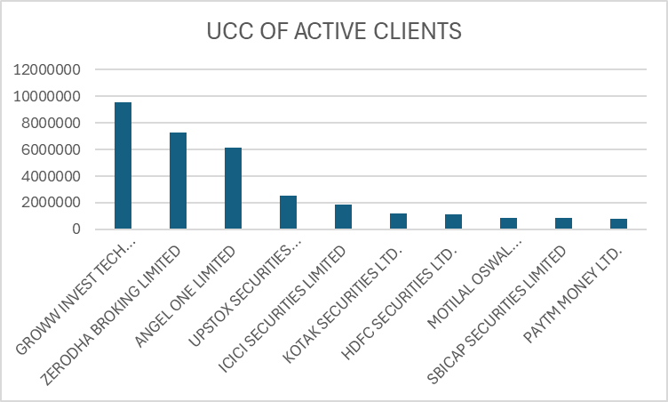
Figure 1: UCC of Active Clients
(Source: NSE Survey Data)
The industry structure is in favour of this argument. The data of active clients in NSE indicate that the market is dominated by a few large platforms: Growth with 21.9% market share, Zerodha with 16.7%, Angel One with 14.0%, and Upstax with 5.8%. The top 10 platforms alone will represent over 73.8% of the cumulative market share, thus suggesting that a fairly small number of apps can have a very large share of active investors.
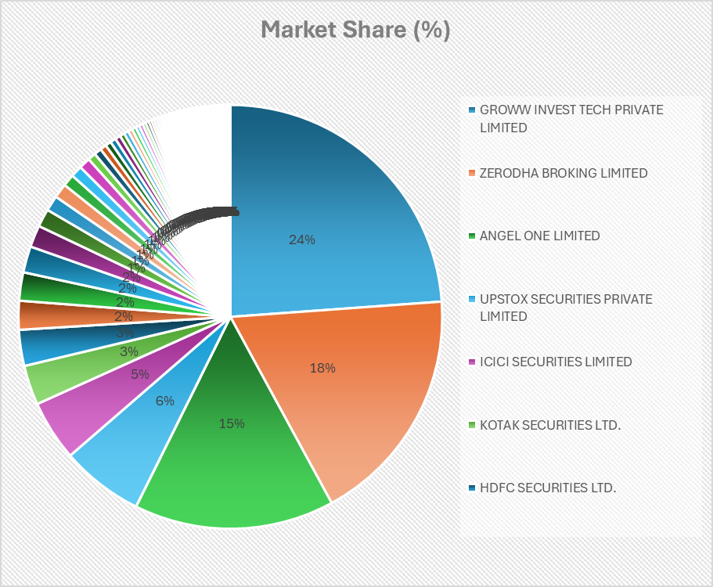
Figure 2: Market Share (%)
(Source: NSE Survey Data)
This is the concentration which is of analytical significance. In case the large platforms include educational applications, explainers, and onboarding to their systems, they will be able to reach a massive segment of the investor base within a few seconds. In fact, these platforms are already moving this direction with educational blogs, video explainers, courses, WebInars, in-app learning sections. The outcome is in a market where investment apps are becoming an infrastructure that provides financial literacy in addition to being a trading intermediary. This is what makes them important to a blue-ocean strategy where they will be able to transform the latent demand into participation by alleviating informational and behavioural friction (Guo et al., 2025).

METHODOLOGY
The research is a quantitative, cross-sectional study that uses the support of financial education, platforms, and behavioural barriers to determine the influence of these factors on investor participation. The analysis will be based on two sections of the SEBI Investor Survey 2025, namely the intermediary data and the respondent data, which are narrowed down to NCR. The combination of the two sets of data enables the study to contrast institutional perceptions of the investor behaviour with the responses of the investors on their part, which enhances the interpretive effect of the results. The questions of the survey are multi-response (MRQs); thus, the answers were converted to binary variables, with 1 as the selection of an option and 0 as non-selection (Dudziński et al., 2025). This method of coding is suitable since the questionnaire indicates reasons, barriers, triggers, and support needs, and not scale-based attitudes. The study thus considers each block of questions to be a set of choices in the broader construct, say motivation, barriers, and education needs, or account-support requirements.
The analysis will be carried out in four phases. In the first place, descriptive frequency analysis determines the most popular motivations, obstacles, facilitators, and support requirements. Second, the variation of these patterns in the main demographic characteristics, like income, is investigated with the help of the cross-tabulation. Third, a test of the grouped variables as underlying dimensions is done using exploratory factor analysis (EFA) (Tang et al., 2024; Yang et al., 2025). The EFA outcomes indicate that the data is appropriate to perform the factor analysis with the Kaiser-Meyer-Olkin at 0.638, significant, and the Bartlett test is significant (p < .001) (Alzaben et al., 2024). A three-factor structure is established with the probabilities of the elements being stable, and the resultant component matrix is used to justify the next round of analysis with conceptually meaningful groupings.
Lastly, the relationships between education, support services, awareness, and behavioural concerns are tested by using Partial Least Squares Structural Equation Modeling (PLS-SEM) (Pereira et al., 2024; Romo et al., 2024). This technique is appropriate, as the research is prediction-based and grouped constructs based on items of the survey that are binary-coded. The PLS-SEM framework further enables the research to determine the level of explanatory power based on R² and also to determine the strength of structural pathways amongst the constructs (Rosak-Szyrocka & Tiwari, 2023; Radić et al., 2025). Similar to recent works that use SmartPLS to investigate financial literacy and investment decision studies, the method offers a stringent means to test the effects of education and online assistance in enabling participation in the market (Yanuarti Loebiantoro et al., 2024).

DATA ANALYSIS & RESULTS

Descriptive Findings
The descriptive analysis indicates that there is an evident disequilibrium between the motivation of investors and barriers. The findings of the respondent dataset reveal that motivational drivers (SS_BB1) are exceptionally weak across the categories and most of the options have less than 1% positive responses. This is a sign that inherent or perceived benefits such as higher returns, diversification or long-term growth is not enough to create action among prospective investors.

SS_BB2: Barriers
Option | Yes (%)
Lack of knowledge | 4.2%
Don’t know how to start | 3.8%
Information overload | 3.3%
Fear of losing money | 4.5%
Uncertainty about returns | 2.7%
Lack of trust | 4.0%
High initial investment requirement | 3.7%
Lack of money | 1.7%
Long-term nature | 3.0%
Too many options | 2.5%
Better alternatives | 2.5%
High fees | 2.1%
Regulatory concerns | 4.4%
Lack of time | 1.0%
Delay in receiving money | 1.5%
Too many documents | 0.9%
Advised not to invest | 0.7%
No local language platform | 0.2%
Other | 0.0%

On the other hand, the barriers to participation frequency (SS_BB2) are comparably greater particularly in the aspects of lack of knowledge, fear of financial loss, lack of trust and regulatory issues. These findings support the fact that the most significant are informational and psychological deterrents as opposed to structural ones. Such aspects as time or documentation needs are not as significant as cognitive and behavioural limitations. The deeper the enabler variables (SS_BB3) give an insight. The responses indicate that simplified processes, user-friendly platforms, and financial education enhancement are some of the most desirable conditions that can trigger the participation. Surprisingly, the reaction to enhanced education on stock investment and easy and simple investment process has comparatively more positive reaction than the other enabling factors.
These results are informed by information on the halfway data (Q13-Q16). Reports of numerous intermediaries indicate that investors need help with KYC processes (64.3%), account management (57.9%), and online onboarding (56.4%), meaning that the basic concept of the operations is not the same. Moreover, the risk perceptions that remain are highlighted by some of the problems that are associated with exit, including market volatility (65.9%), and financial losses (over 50%). On the whole, the descriptive statistics vividly show that the number of barriers prevails, and motivation is low and requires specific financial education and support systems (Baveja & Verma, 2024; Lakoni et al., 2023).

Cross-Tabulation Analysis
The cross-tabulation analysis was done to analyze the relationship between the level of income and the important constructs, especially the motivation and barriers.

Association of Income with Motivation
Income Group | Motivation (%)
Do not disclose | 1.2%
No income | 2.0%
₹5k–10k | 0.9%
₹10k–15k | 1.8%
₹15k–20k | 2.3%
₹20k–30k | 3.9%
₹30k–40k | 4.0%
₹40k–50k | 3.9%
₹50k–60k | 6.8%
₹80k–1L | 5.4%

The findings indicate that there is a low level of investment motivation that does not depend on the income levels, except for a low variation. Even in the higher-income groups, the percentage of respondents who report motivational drivers is less than meaningful levels. This means that one may not necessarily invest because of financial capacity, and it further reinforces the notion that behavioural and informational factors are more important.

Association of Income with Barriers
Income Group | Barriers (%)
Do not disclose | 10.0%
No income | 15.7%
₹5k–10k | 7.5%
₹10k–15k | 13.4%
₹15k–20k | 20.8%
₹20k–30k | 17.2%
₹30k–40k | 18.1%
₹40k–50k | 14.7%
₹50k–60k | 15.4%
₹60k–80k | 10.0%
₹80k–1L | 13.5%

However, the relationship between barriers and income, in turn, is not as obvious. The middle-income groups (₹15,000-40,000 range) are facing relatively higher perceived barriers particularly in the dimensions of knowledge gap, risk perception and uncertainty. The lower-income groups also exhibit barriers but these tend to be connected with the inability to afford them. The increases in the income groups report relatively lower barriers, though they are not non-existent.
This trend shows that the middle-income group is an important target group to be targeted. The people have the financial ability to invest but are limited by ignorance, fear of losing, and not knowing what to do. On the whole, the results of the cross-tabulation confirm the main thesis of the work, where the barriers play a more important role than motivation, and their influence differs by the income groups, with the middle-income groups being especially affected (Baveja & Verma, 2024; Lakoni et al., 2023).

Factor Analysis (EFA Results)
Exploratory Factor Analysis (EFA) was utilized to figure out latent constructs within the data of intermediates.

Exploratory factor analysis
KMO and Bartlett's Test
Kaiser-Meyer-Olkin Measure of Sampling Adequacy. |  | .638
Bartlett's Test of Sphericity | Approx. Chi-Square | 466.431
Bartlett's Test of Sphericity | df | 45
Bartlett's Test of Sphericity | Sig. | .000
The Kaiser-Meyer-Olkin (KMO) measure of sampling adequacy was found to be 0.638, which implies that it is sufficiently suitable to conduct the factor analysis. The Test of Sphericity by Bartlett was statistically significant (p < 0.001), which proved that the variables are correlated enough to warrant factor extraction.

Rotated Component Matrix
 | Component
 | 1 | 2 | 3
IRBC1 |  |  | .754
IRBC2 |  |  | .637
IEA1 | .698
IEA2 | .701
IEA3 | .515
IASS3 |  | .642
IASS4 |  | .728
IASS5 |  | .592
Extraction Method: Principal Component Analysis.
Rotation Method: Varimax with Kaiser Normalization.
a. Rotation converged in 5 iterations.
Discriminant validity
 | Investment risk and behavioural concern | Investor account support services
Investment risk and behavioural concern
Investor account support services | 0.048
Investor education and awareness | 0.241 | 0.521

The results of the analysis ended up with a clean three-factor structure with no dropped variables having high factor loading above 0.5. The constructs that were extracted were understood in the following way:
- Investor Education and Awareness - capturing variables based on financial knowledge, product awareness, and learning requirements.
- Account Support Services - indicates support in the areas of onboarding, KYC, account management, and processes.
- Risk and Behavioural Concerns- this represents psychological issues like fear of loss, concerns of volatility, and trust issues.
The factor structure is fairly aligned with the conceptual model of the study and also provides a statistically validated basis of further structural modeling (Baveja and Verma, 2024; Lakoni et al., 2023).

PLS-SEM Results
Partial Least Squares Structural Equation Modeling (PLS-SEM) was used to analyse the relationships between education, support services, awareness, and behavioural outcomes.
- Intermediary Data Model
In order to maintain clarity and consistency of the PLS-SEM model, the study have operationalised the main constructs and their indicators in the following manner:
Investor Education & Awareness (IEA): This relates to investors' financial knowledge and the need for financial education.
- IEA1: Knowledge about financial products and investment opportunities
- IEA2: Knowledge of investment processes and market mechanism
- IEA3: Need for financial and learning assistance
Investor Account Support Services (IASS): This indicates the level of support needed by investors to support their investment accounts.
- IASS3: Assistance in account opening and KYC process
- IASS5: Support in managing an account and transactional matters
Investment Risk & Behavioural Concern (IRBC): This factor represents the psychological and/or risk-based factors that affect investment.
- IRBC1: Concerns about losing money
- IRBC2: Fears of risk and uncertainty
These definitions link the variables to the constructs in the structural model.
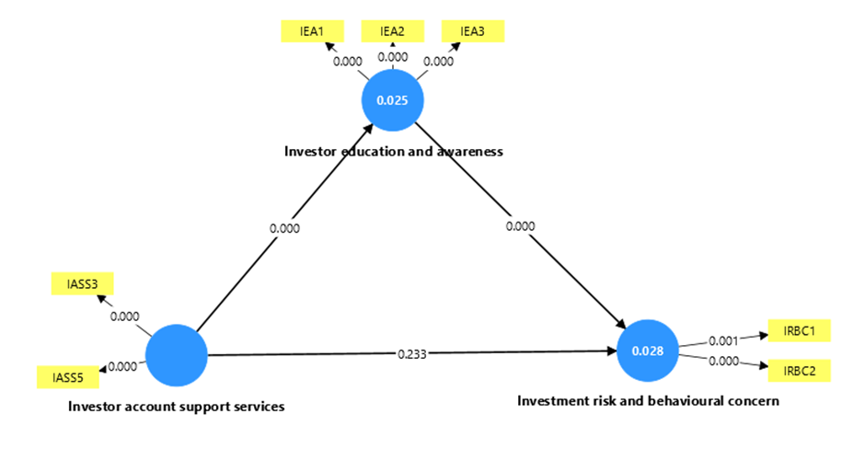
Figure 3: PLS-SEM Path Model (Intermediatory data)
The explanatory power of the structural model, which uses intermediary data, is very low. The risk/behavioural concerns (R²) and investor awareness (R²) are 0.028 and 0.025, respectively. These values indicate that the independent variables (primarily education and support services) can only explain a small proportion of variance in the dependent constructs. This shows that the current investor education programmes and support systems are poor in terms of addressing the behavioural as well as informational problems underlying investors. Although intermediate players have realized the relevance of education, there does not seem to be much effect (Nathanael & Ngollo, 2025).
- Respondent Data Model
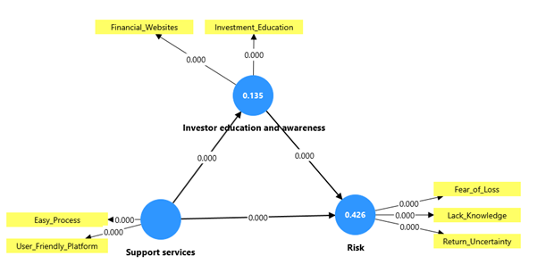
Figure 4: PLS-SEM Path Model (Respondent data)
The respondent data-driven model gives slightly higher findings. Investor awareness has a moderate explanatory power with an R² of 0.135. More to the point, the R² value of risk and behavioural concerns is 0.426, indicating that a significant part of behavioural outcomes can be attributed to the model. These results show that the barriers of behaviour are quite entrenched and they dominate in influencing investment decisions. Although financial education helps to enhance awareness, the psychological limitations of fear of loss, uncertainty, and lack of trust cannot be completely overcome by financial education. In sum, the results of the PLS-SEM indicate a very important finding that education is positively but weakly associated, whereas behavioural factors have a much greater effect on investment behaviour (Nathanael & Ngollo, 2025).

Key Integrated Insight
The results of the descriptive analysis, cross-tabulation, factor analysis, and PLS-SEM are combined and culminate in one main point that financial education enhances awareness but does not necessarily lead to participation. Although the barriers related to knowledge are critical, the behavioural and psychological barriers are the most critical issues in determining the investor's decisions. This means that there should be good support services, streamlined processes, and behavioural interventions to accompany education. As long as these dimensions are not taken into consideration, the effect of financial education will not be significant. Hence, an integrated strategy incorporating education, usability, and behavioural design is vital in boosting participation in the securities market.

DISCUSSION
The results of the present research coincide with the literature on financial literacy and behavioural finance, as well as contribute to the topic and expand it to the impact of digital platforms. The findings are consistent with previous studies that reveal that financial literacy is one of the determinants of investment behaviour. However, the study also indicates that knowledge alone cannot be a motivating factor to take part. The hegemony of the obstacles observed in the descriptive and the cross-tabulation analysis conforms to the behavioural finance theories, which emphasise the significance of psychological factors, such as fear, uncertainty, and distrust. These findings also agree with SEBI survey findings which show that the most significant inhibitors are complexity and lack of understanding. The multidimensionality of the issue which investor challenges have is also proven by the factor analysis as it distinguishes between education, operational support and behavioural issues (Manoj Kumar et al., 2024). This supports the importance of combined interventions as opposed to individual interventions.
Findings of the PLS-SEM give a more in-depth insight into such relationships. Although financial education enhances awareness, its effects are not very strong compared to behavioural influences. This brings to the fore a critical disconnection between the acquisition of knowledge and behaviour change. Here, investment apps come in as significant yet incomplete solutions. They have managed to open access doors and enhance access to information. Nevertheless, their existing strategy might be too weak to deal with behavioural biases and offer the new investors the extent of advice needed (Nathanael & Ngollo, 2025; Freibauer et al., 2024). Investment apps are evolving from a transactional platform to an educational ecosystem, but their current effect is not high enough to dismantle the effects of investor barriers comprehensively.

CONCLUSION
This paper proves that, as much as financial education is important in enhancing investor awareness, it is not enough to propel any meaningful participation in the securities market. The findings indicate that the most predominant barriers continue to be behavioural constraints, including fear of loss, mistrust and perceived complexity. Application application and digital spaces have the potential to become agents of financial literacy as the analysis has demonstrated. However, they will be effective to the extent that they will be integrative of education and behavioural support and simplified user experiences. The Indian securities market provides a huge blue ocean opportunity and a huge untapped base of investors. The problem of awareness to participation should be more of a holistic one, than information dissemination.

IMPLICATIONS
Investment platforms should adopt an education-first approach with a focus on simplified, structured, and guided learning. It can be simplified through onboarding that includes detailed instructions and tutorials and customized advice to create user confidence. Moreover, platforms should also have behavioural nudges, such as risk warnings, goal-based investing products, and decision support, to overcome psychological barriers. Policymakers are supposed to improve Investor Education Programs (IEP) with the digital consumption trends. Regional language content, visual learning, and delivery on a platform basis should be given attention. In addition, the policies should not be simply focused on increasing the level of awareness but also to reduce the behavioural barriers through intervention with particular measures in order that the financial inclusion initiatives can be translated into a tangible market presence.

References
Adielyani, D. (2025). FINTECH ACCESS AND DIGITAL FINANCIAL LITERACY ON FINANCIAL BEHAVIOR IN THE DIGITAL ERA: THE MEDIATION ROLE OF FINANCIAL SELF-CONTROL. Among Makarti, 18(2), 285. https://doi.org/10.52353/ama.v18i2.912
Aidil Fadli, J. (2024). Measuring the Level of Digital Financial Literacy Among Generation Y and Z in Indonesia. Jurnal Ilmiah Manajemen Kesatuan, 12(5), 1891–1898. https://doi.org/10.37641/jimkes.v12i5.2813
Albuainain, A., & Ashby, S. (2025). Enablers and Barriers in FinTech Adoption: A Systematic Literature Review of Customer Adoption and Its Impact on Bank Performance. FinTech, 4(3), 49. https://doi.org/10.3390/fintech4030049
Alzaben, A. S., Almansour, M., Alzahrani, H. S., Alrumaihi, N. A., Alhamedi, N. M., Albuhayjan, N. A., & Aljammaz, S. A. (2024). Development of Valid and Reliable Questionnaire to Evaluate Knowledge, Attitude, and Practices (KAP) of Lifestyle Medicine Domains. Healthcare, 12(16), 1652. https://doi.org/10.3390/healthcare12161652
Angel One. (2026a). Knowledge center. Retrieved April 14, 2026, from https://www.angelone.in/knowledge-center
Angel One. (2026b). User manual: Home. Retrieved April 14, 2026, from https://www.angelone.in/knowledge-center/user-manual/home
Angel One. (2026c). Smart Money: Trading courses. Retrieved April 14, 2026, from https://www.angelone.in/smart-money/trading-courses
Anggraini, L. D., Santoso, A. R., & Reyes, A. V. (2025). The Role of Fintech Adoption in Enhancing Financial Literacy and Financial Well-Being in Emerging Markets. Journal of Economics and Management, 3(3), 123–130. https://doi.org/10.70716/ecoma.v3i3.337
Aoun, D., Rahal, R., Sfeir, L., & Jabbour Al Maalouf, N. (2026). Understanding Millennials’ Financial Behavior: The Role of Fintech Adoption, Financial Literacy, and the Mediating Effect of Financial Attitudes in a Crisis-Affected Emerging Economy. International Journal of Financial Studies, 14(2), 35. https://doi.org/10.3390/ijfs14020035
Baveja, G. S., & Verma, A. (2024). Impact of Financial Literacy on Investment Decisions and Stock Market Participation using Extreme Learning Machines (Version 2). arXiv. https://doi.org/10.48550/ARXIV.2407.03498
Dudziński, Ł., Tymiński, J., Kubiak, T., Czyzewski, L., Wyzgal, J., & Gałązkowski, R. (2025). Determinants of health status and health-related behaviors among polish firefighters: a nationwide survey-based study. Frontiers in Nutrition, 12. https://doi.org/10.3389/fnut.2025.1682811
Freibauer, J., Grawert, S., & Rieger, M. O. (2024). The effects of trading apps on investment behavior over time. The European Journal of Finance, 1–25. https://doi.org/10.1080/1351847x.2024.2401604
Goso, G., Jasman, J., Husmaruddin, H., & Alam, S. (2025). Digital Financial Literacy and Decision-Making: A Behavioural Management Model for Digital Natives. Jurnal Minds: Manajemen Ide Dan Inspirasi, 12(2), 429–440. https://doi.org/10.24252/minds.v12i2.56161
Goso, G., Jasman, J., Husmaruddin, H., & Alam, S. (2025). Digital Financial Literacy and Decision-Making: A Behavioural Management Model for Digital Natives. Jurnal Minds: Manajemen Ide Dan Inspirasi, 12(2), 429–440. https://doi.org/10.24252/minds.v12i2.56161
Groww. (2026a). Investment basics. Retrieved April 14, 2026, from https://groww.in/p/investment-basics
Groww. (2026b). Groww Digest: Daily and weekly financial news updates. Retrieved April 14, 2026, from https://groww.in/digest
Groww. (2026c). Stock market basics. Retrieved April 14, 2026, from https://groww.in/p/stock-market-basics
Guo, X., Sun, Q., & Yeung, B. (2025, September 27). Stock market participation and financial education in the digital age. VoxEU, Centre for Economic Policy Research. https://cepr.org/voxeu/columns/stock-market-participation-and-financial-education-digital-age
Gupta, Y. (2025). Behavioral finance in reatail investing - an Indian perspective. IOSR Journal of Business and Management, 27(10), 81–93. https://doi.org/10.9790/487x-2710078193
Ha, D., & Nguyen, K. (2024). Unlocking financial access in a developing country amidst COVID-19: the impacts of financial literacy and fintech. Journal of the Asia Pacific Economy, 30(4), 1574–1610. https://doi.org/10.1080/13547860.2024.2386825
Islam, A., & Muhammad Saifuddin Khan. (2024). The role of financial literacy, digital literacy, and financial self-efficacy in FinTech adoption. Investment Management and Financial Innovations/Investment Management & Financial Innovations, 21(2), 370–380. https://doi.org/10.21511/imfi.21(2).2024.30
K Arjun Goud, Dr. K. V. R. Satya Kumar, & Dr. P.Chakradhar. (2024). A STUDY ON BEHAVIOURAL FINANCE AND ITS IMPACT ON DECISION MAKING OF AN INVESTMENT. EPRA International Journal of Economics, Business and Management Studies, 104–115. https://doi.org/10.36713/epra16186
Khanna, K. (2026). The Role of Mobile Investment Apps in Encouraging First-Time Investors: Evidence from Groww and Zerodha. International Journal For Multidisciplinary Research, 8(1). https://doi.org/10.36948/ijfmr.2026.v08i01.66995
Lakoni, I., Nurazi, R., Aziza, N., & Novitasari, N. (2023). Relationship of financial literacy to stock market participation. Journal of Economics and Business Letters, 3(6). https://doi.org/10.55942/jebl.v3i6.270
Lakoni, I., Nurazi, R., Aziza, N., & Novitasari, N. (2023). Relationship of financial literacy to stock market participation. Journal of Economics and Business Letters, 3(6). https://doi.org/10.55942/jebl.v3i6.270
Lakoni, I., Nurazi, R., Aziza, N., & Novitasari, N. (2023). Relationship of financial literacy to stock market participation. Journal of Economics and Business Letters, 3(6). https://doi.org/10.55942/jebl.v3i6.270
Lu, Z., Wu, J., Li, H., & Galloway, B. (2023). Digital finance and stock market participation: The case of internet wealth management products in China. Economic Systems, 101148–101148. https://doi.org/10.1016/j.ecosys.2023.101148
Lu, Z., Wu, J., Li, H., & Galloway, B. (2024). Digital finance and stock market participation: The case of internet wealth management products in China. Economic Systems, 48(1), 101148. https://doi.org/10.1016/j.ecosys.2023.101148
Lye, C.-T., Tay, L.-Y., Ng, T.-H., & Ahmad-Nazmi, A. N. (2025). A systematic literature review of fintech, financial inclusion and vulnerable groups. Discover Sustainability, 6(1). https://doi.org/10.1007/s43621-025-02368-2
Manoj Kumar M, Nasser Almuraqab, Immanuel Azaad Moonesar, Braendle, U. C., & Rao, A. (2024). How critical is SME financial literacy and digital financial access for financial and economic development in the expanded BRICS block? Frontiers in Big Data, 7. https://doi.org/10.3389/fdata.2024.1448571
Mohapatra, N., Das, M., Shekhar, S., Singh, R., Khan, S., Tewari, L. M., Félix, M. J., & Santos, G. (2025). Assessing the Role of Financial Literacy in FinTech Adoption by MSEs: Ensuring Sustainability Through a Fuzzy AHP Approach. Sustainability, 17(10), 4340. https://doi.org/10.3390/su17104340
Nathanael, A. C., & Ngollo, M. I. (2025). Exploring the Fintech, financial literacy, and stock market participants nexus in the Dar es Salaam Stock Exchange, Tanzania. Asian Management and Business Review, 383–401. https://doi.org/10.20885/ambr.vol5.iss2.art9
Nilawati, O., & Ainiah, L. (2025). Financial Literacy and Investment Decision-Making Tendencies: A Comparative Study between Millennials and Gen Z in Indonesia. International Journal of Social Science Research and Review, 8(7), 452–466. https://doi.org/10.47814/ijssrr.v8i7.2838
Niranjan B, Muthumani S, & Dr. Priyada Vinod. (2025). A Study on the Impact of Trading Apps on Enhancing the Financial Literacy of First-Time Retail Investors. International Journal of Contemporary Research in Multidisciplinary. https://doi.org/10.5281/ZENODO.17481293
Pant, S., & Agarwal, M. (2024, March 5). Digital financial literacy and fintech adoption. ResearchGate; unknown. https://www.researchgate.net/publication/378715559_Digital_financial_literacy_and_fintech_adoption .
Pereira, L. M., Sanchez Rodrigues, V., & Freires, F. G. M. (2024). Use of Partial Least Squares Structural Equation Modeling (PLS-SEM) to Improve Plastic Waste Management. Applied Sciences, 14(2), 628. https://doi.org/10.3390/app14020628
Phung, T. M. T., & Nguyen, L. D. (2025). The effect of financial literacy and fintech usage on income levels: a study in Vietnam. Journal of Electronic Business &amp; Digital Economics, 4(2), 317–333. https://doi.org/10.1108/jebde-03-2025-0019
Radić, A., Bobek, S., Arsić, S., Nikolić, Đ., & Sternad Zabukovšek, S. (2025). An Integrated PLS-SEM-TOPSIS-Sort Approach for Assessing ERP Solutions Acceptance Across Various Industries. Information, 16(11), 954. https://doi.org/10.3390/info16110954
Rohaeni, N., Meutia, M., Indriana, I., & Januarsi, Y. (2026). Financial literacy, FinTech, and inclusion for MSME growth in Banten province. Discover Sustainability, 7(1). https://doi.org/10.1007/s43621-026-02869-8
Romo, R., Alejo-Reyes, A., & Orozco, F. (2024). Statistical Analysis of Lean Construction Barriers to Optimize Its Implementation Using PLS-SEM and PCA. Buildings, 14(2), 486. https://doi.org/10.3390/buildings14020486
Rosak-Szyrocka, J., & Tiwari, S. (2023). Structural Equation Modeling (SEM) to Test Sustainable Development in University 4.0 in the Ultra-Smart Society Era. Sustainability, 15(23), 16167. https://doi.org/10.3390/su152316167
Sancak, B., & Demirbaş, D. (2024). Finansal Okuryazarlığın Yatırım Piyasalarına Katılım Üzerindeki Etkisi: Üniversite Öğrencileri Üzerine Bir İnceleme. Journal of Economic Policy Researches / İktisat Politikası Araştırmaları Dergisi, 11(2), 204–225. https://doi.org/10.26650/jepr1406361
Tang, K., Yuan, J., & Luo, L. (2024). Validity evaluation of the Health Information Preferences Questionnaire among college students. Frontiers in Public Health, 12. https://doi.org/10.3389/fpubh.2024.1249621
Upstox. (2026). Learning center. Retrieved April 14, 2026, from https://upstox.com/learning-center/
Yang, Y., Xu, S., Chen, S., Tian, J., & Chen, B. (2025). Development and validation of a questionnaire for laboratory medicine knowledge and attitudes in clinical medical interns. Frontiers in Medicine, 12. https://doi.org/10.3389/fmed.2025.1726666
Yanuarti Loebiantoro, I., Hooi Cheng, E., & Annuar, N. (2024). Smart investing: Unveiling key drivers of strategic investment for investors in the Indonesia Stock Exchange. Investment Management and Financial Innovations, 21(4), 156–169. https://doi.org/10.21511/imfi.21(4).2024.13
Ye, Y., Pu, Y., & Xiong, A. (2022). The impact of digital finance on household participation in risky financial markets: Evidence-based study from China. PLOS ONE, 17(4), e0265606. https://doi.org/10.1371/journal.pone.0265606
Zerodha. (2026a). Varsity: Free stock market and financial education. Retrieved April 14, 2026, from https://zerodha.com/varsity/
Zerodha. (2026b). Varsity modules: Stock market and financial education. Retrieved April 14, 2026, from https://zerodha.com/varsity/modules/
Zerodha. (2026c). Getting started. Varsity. Retrieved April 14, 2026, from https://zerodha.com/varsity/chapter/getting-started/

