Trust Calibration in the Workplace: Understanding How Employees Build and Adjust Confidence in AI During Everyday Work
Table of Contents
Introduction 3
Theme 1: Trust in AI 3
Theme 2: AI Usage and Application 5
Theme 3: Challenges and Risks 6
Theme 4: Organizational Support and Policies 8
Theme 5: Impact on Work and Outcomes 8
Theme 6: Recommendations and Improvements 10
Conclusion 11
References 13

Introduction
The patterns identified through this thematic analysis are based on 14 interview transcripts, which are pooled to discuss six main themes that were identified inductively based on the experiences that people had with AI systems. Trust is displayed in themes as dynamic and cautious, with the factor of practical use, risks, and organizational conditions subject to work, which imply work productivity and ethics.
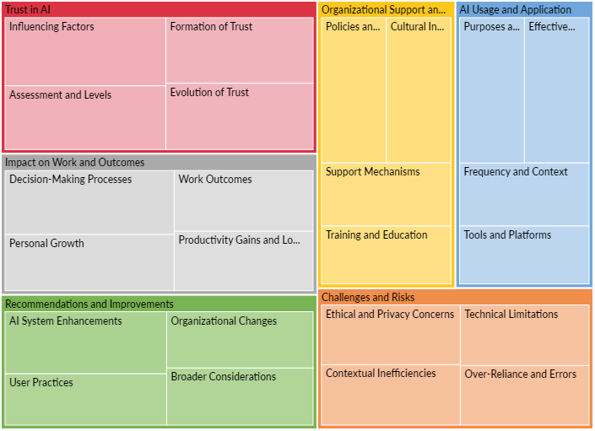
Figure 1: Tree Map

Theme 1: Trust in AI
AI trustability is one of the underlying themes, with trust being described as contingent and changing.
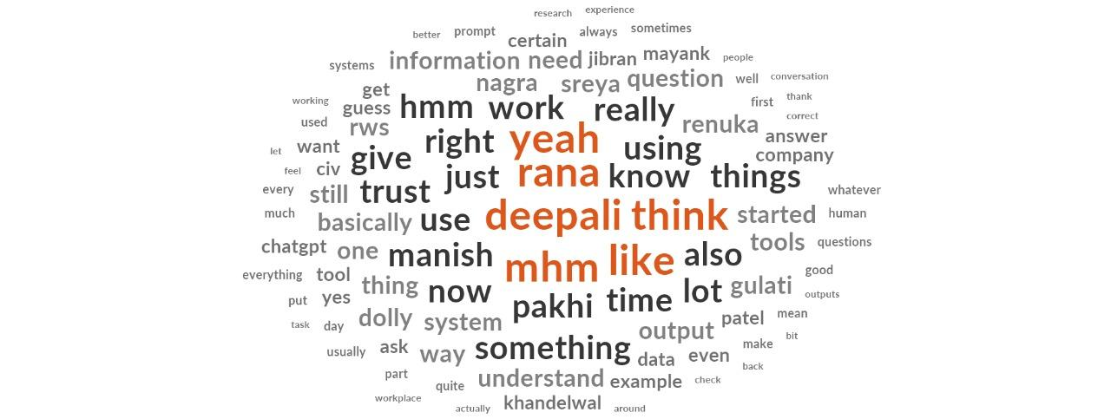
Figure 2: Word Cloud
The participants report an early sense of curiosity, or skepticism, which is usually affected by the speed and relevance of AI, but balanced by issues such as hallucinations.
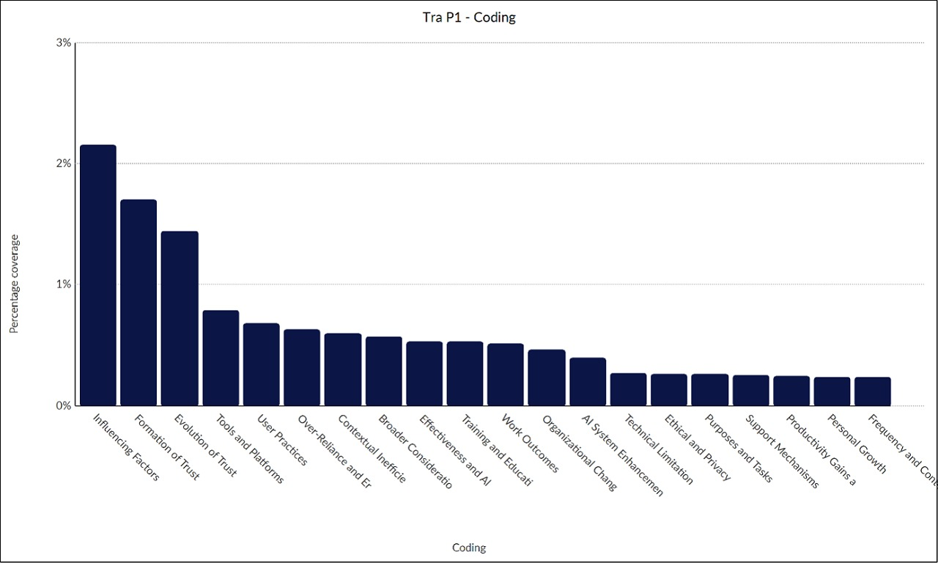
Figure 3: Transcript Participant 1 Coding
The increase in trust comes with experience, such as Participant 14 observed that the inaccuracy decreased with time, yet it is partial and at levels of 40-80% reliability. Personal background and peer pressure are some of the factors that influence perceptions and make trust more of a rational and not absolute value, which may need to be verified manually (Wischnewski et al., 2023, p.3).
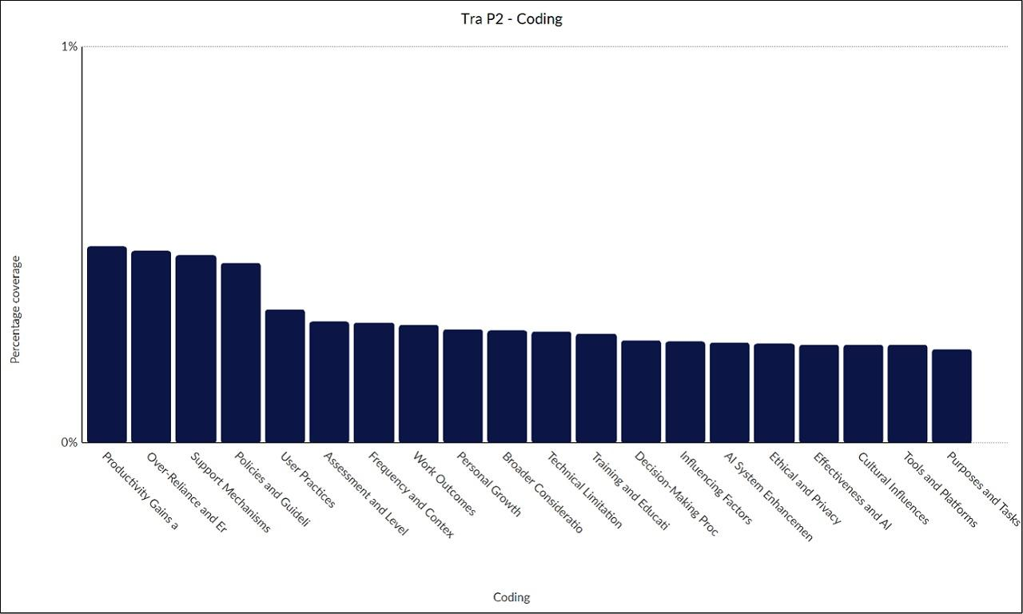
Figure 4: Transcript Participant 2 Coding

Theme 2: AI Usage and Application
This theme shows the practical use of integration, and the tools to be used involving ChatGPT, Copilot, and internal LLMs, which are applied in everyday work to draft emails, encode documents, and brainstorm.
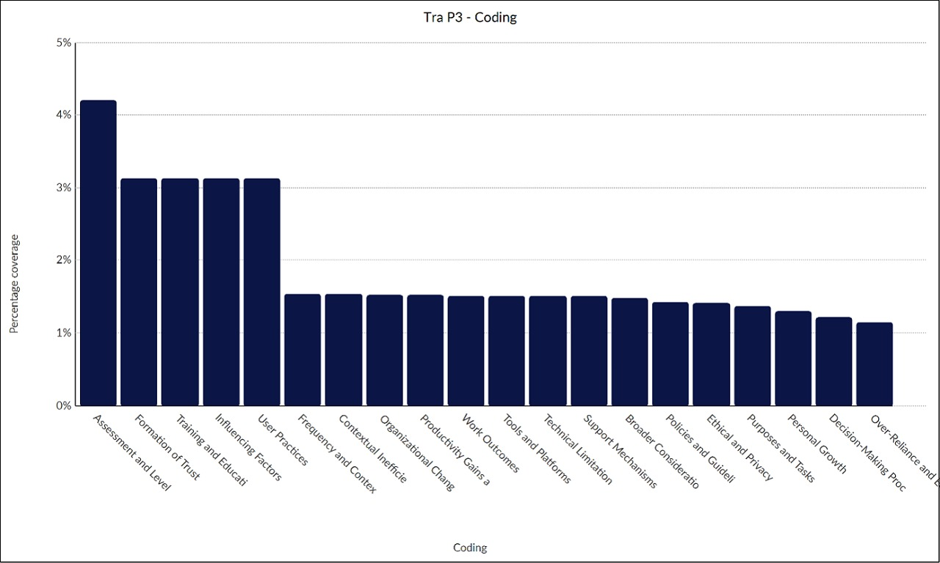
Figure 5: Transcript Participant 3 Coding
Users choose enterprise tools because of their security, and they introduce AI in their work processes, including Outlook, to find something.
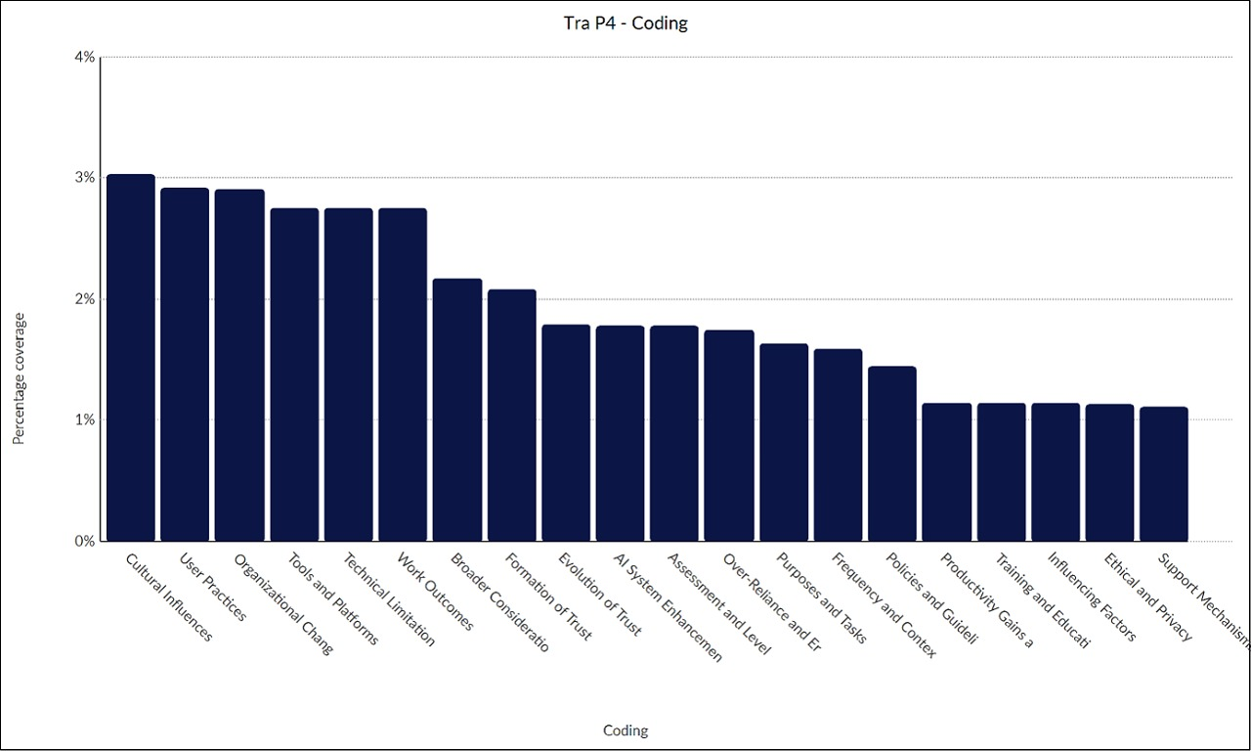
Figure 6: Transcript Participant 4 Coding
The level of effectiveness is variable, where AI will be in line with productivity requirements but requires fine-tuning, like in the case of Participant 7, who should have made changes to his creative work, highlighting AI as a supportive resource and not a solution on its own (Nguyen and Elbanna, 2025, p. 2).
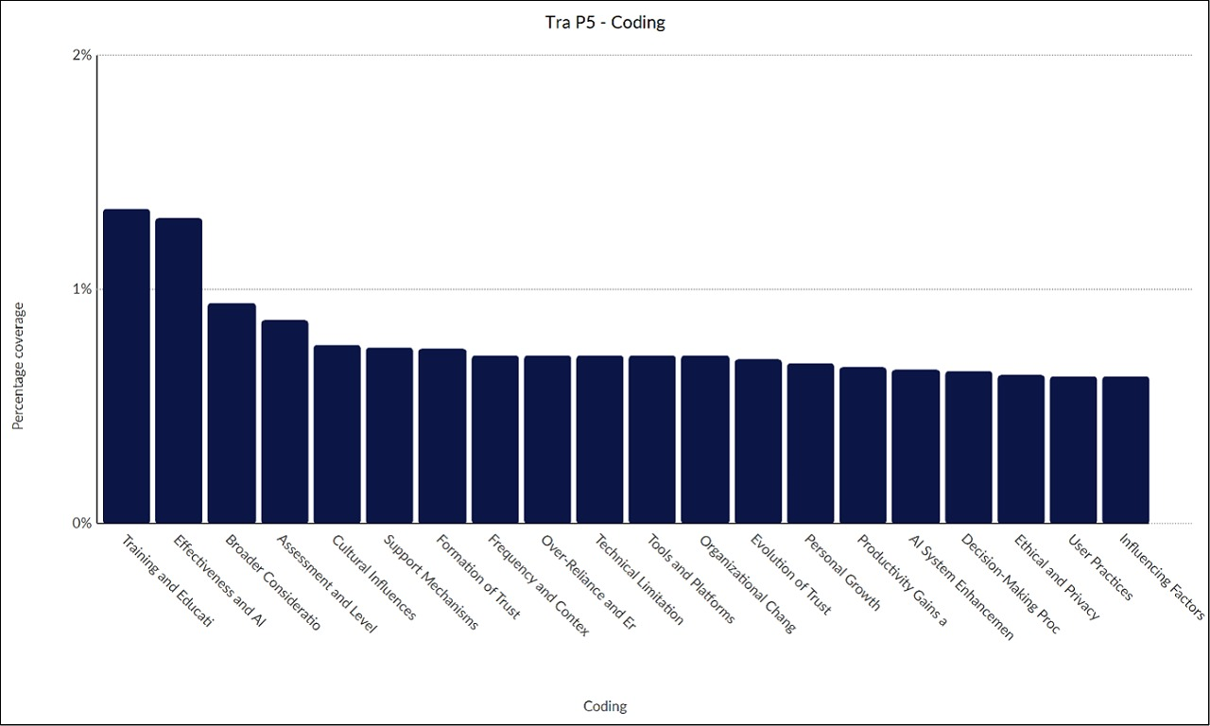
Figure 7: Transcript Participant 5 Coding

Theme 3: Challenges and Risks
This theme indicates restrictions that destroy confidence, such as hallucinations, old information, and privacy invasion.
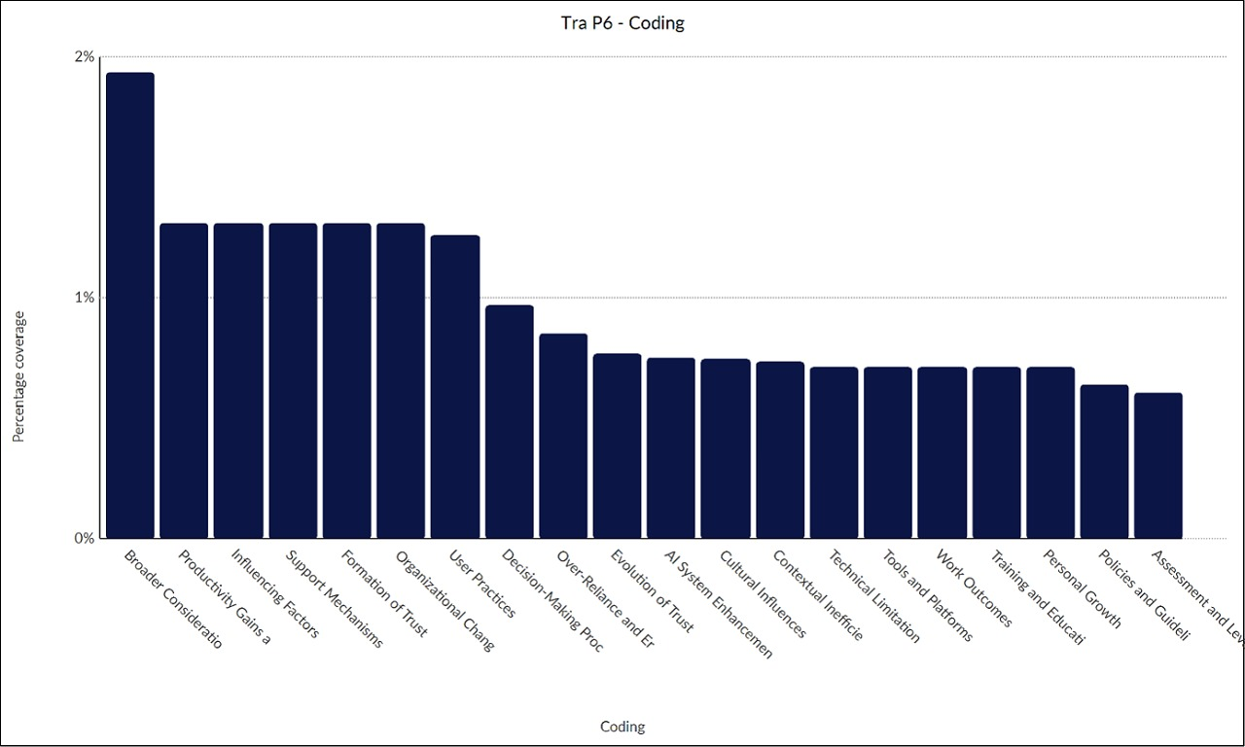
Figure 8: Transcript Participant 6 Coding
The inaccuracy occurs due to such technical problems as the AI smooth-out effect (Participant 14), whereas the ethical concerns, such as biased or copyrighted content (Participant 9), create fears of misuse.
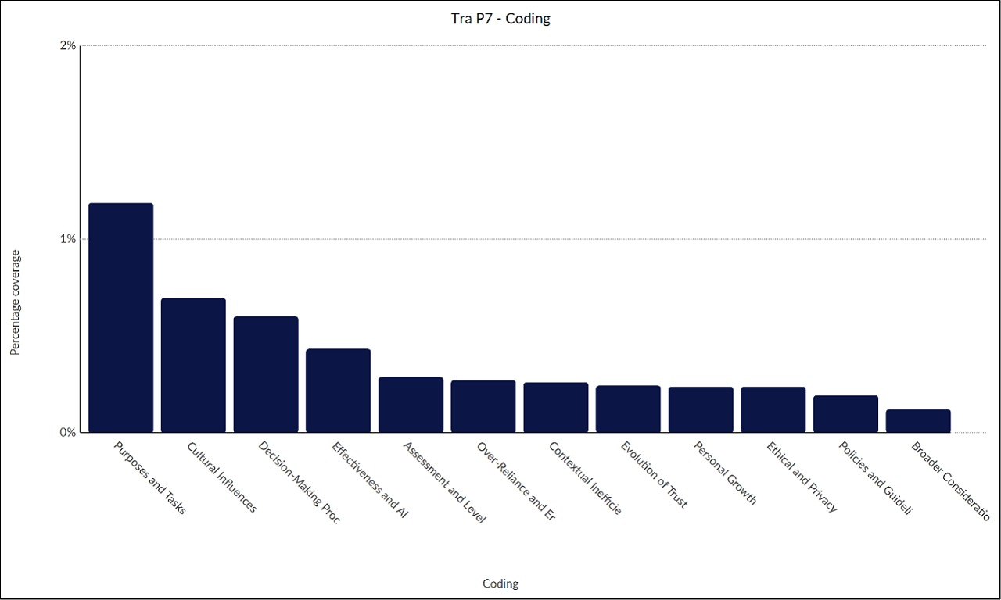
Figure 9: Transcript Participant 7 Coding
The over-reliance leads to mistakes, such as misleading presentation (Participant 1), which focuses on the inability of AI to give complex reasoning or non-language responses (Huang et al., 2023, p. 5).
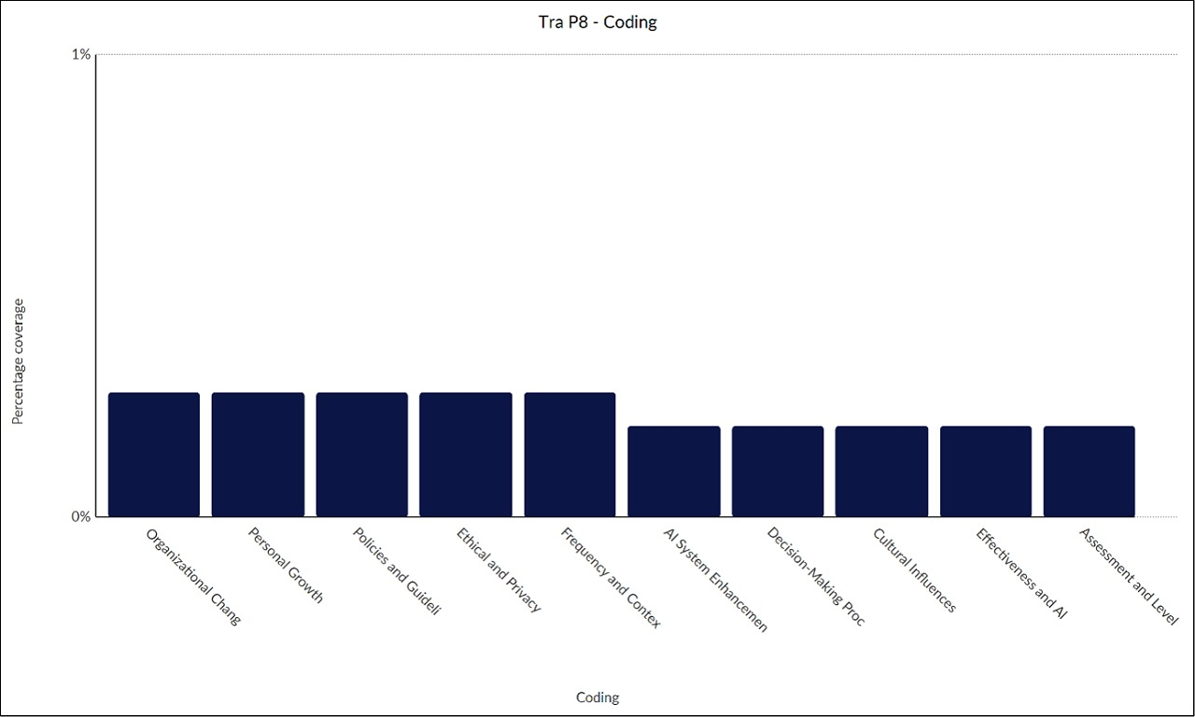
Figure 10: Transcript Participant 8 Coding

Theme 4: Organizational Support and Policies
Organizational Support and Policies demonstrate mixed support for AI adoption. Sandboxes and internal tools (LLMs) referenced by Participant 14 permit safe experimentation, whereas policies determine compliance with the GDPR and data limitations. Fluency develops through training, which is generally informal through peer training; however, gaps still exist, including the fact that Participant 3 reported deficient formal training to overcome hesitancy.

Theme 5: Impact on Work and Outcomes
Effects on work and outcomes demonstrate two impacts that include productivity gains like 80%-time savings (Participant 7) due to automation, but are ineffective because of rework.
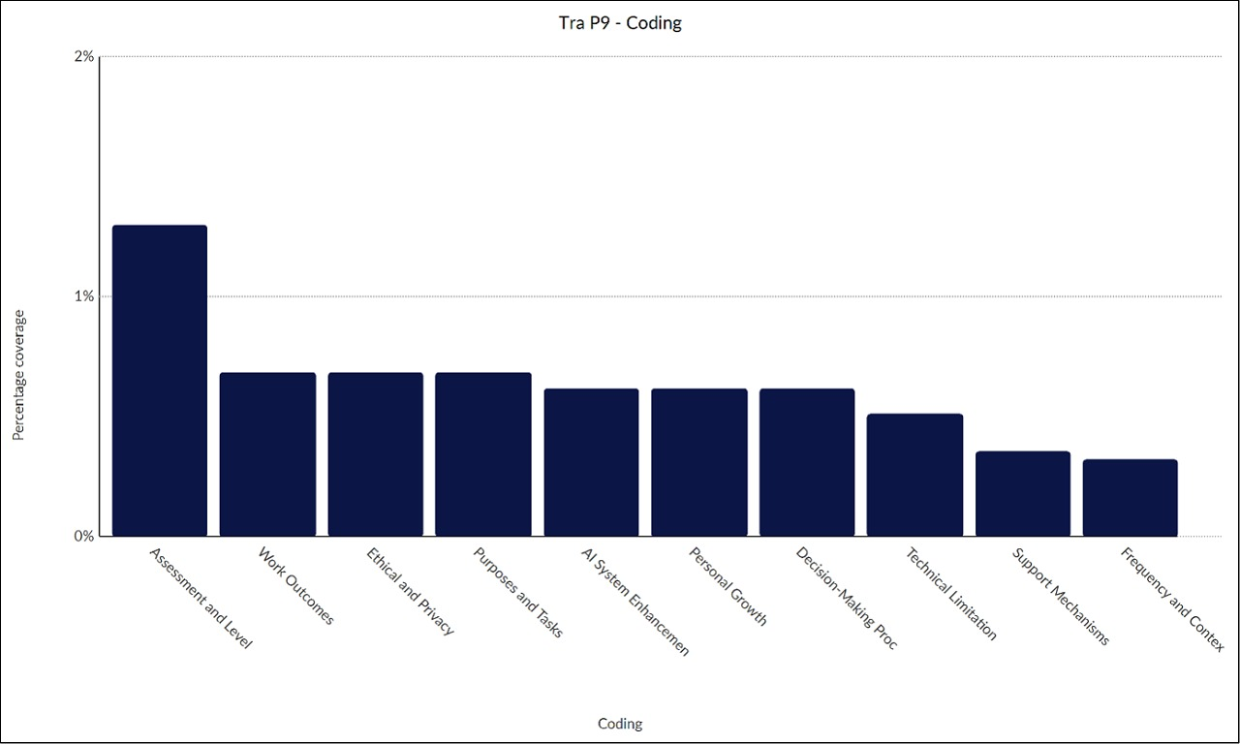
Figure 11: Transcript Participant 9 Coding
Trust also enters into the opportunity of choices, and cross-checking is the most likely way of correcting mistakes, which contributes to the development of skills such as timely engineering.
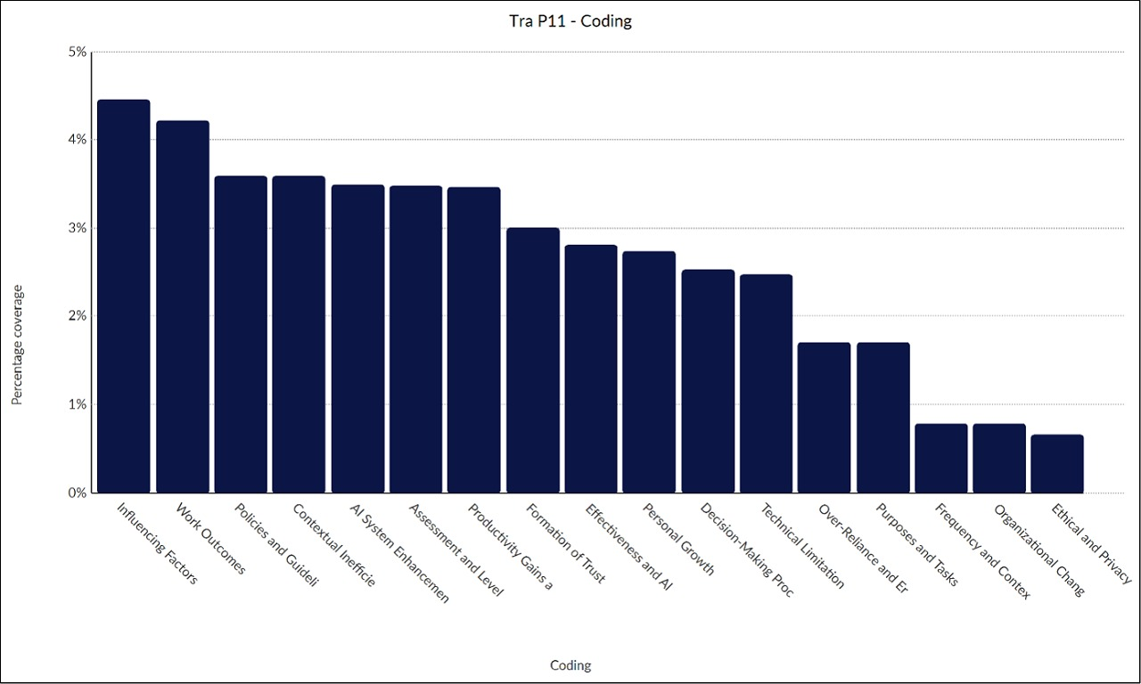
Figure 12: Transcript Participant 11 Coding
The consequences involve ethical dilemmas in deliverables, a trade-off between efficiency and human control (Lucas et al., 2024, p.4).
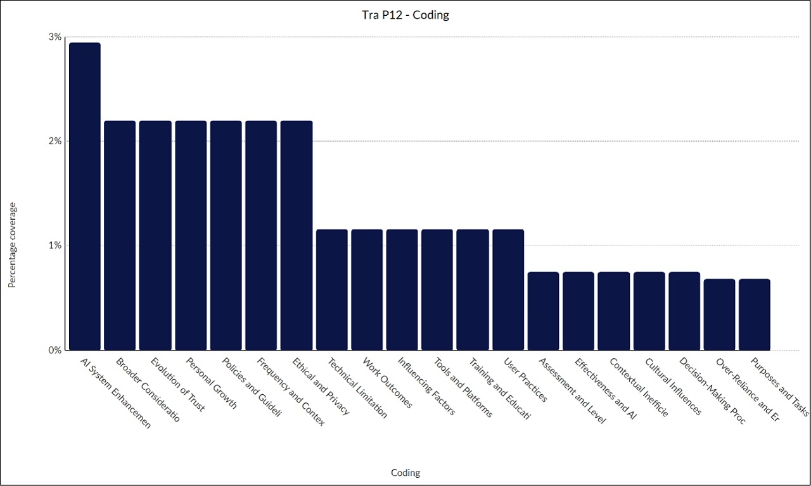
Figure 13: Transcript Participant 12 Coding

Theme 6: Recommendations and Improvements
The theme brings up the requests for improvements on the side of the participants, such as the decreased hallucinations and anthropomorphic reactions (Participant 9).
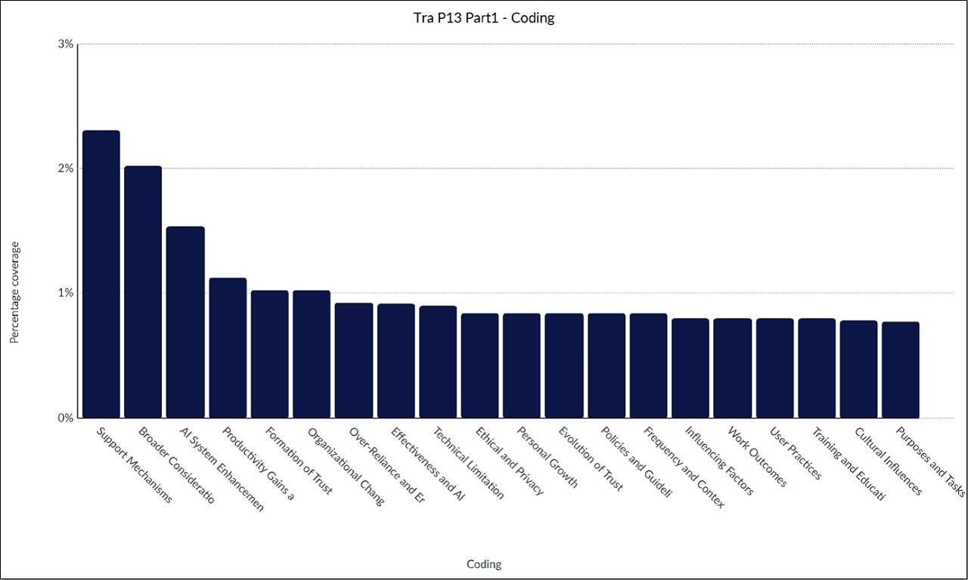
Figure 14: Transcript Participant 13 Part 1 Coding
There are recommendations of organizational modifications, like the incentives to innovation (Participant 14), and user behaviors, including improved prompting, as well as more general ethical standards that can be ensured in order to build sustainable and reliable AI.
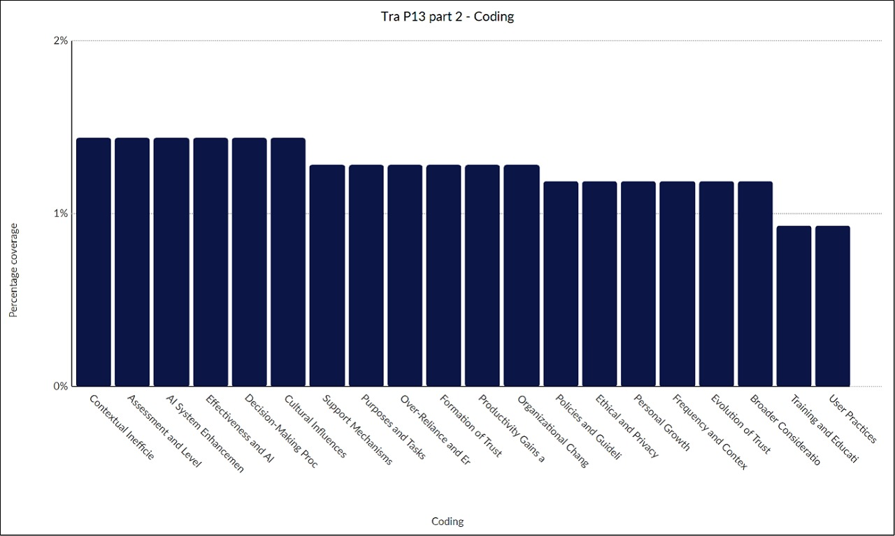
Figure 15: Transcript Participant 13 Part 2 Coding
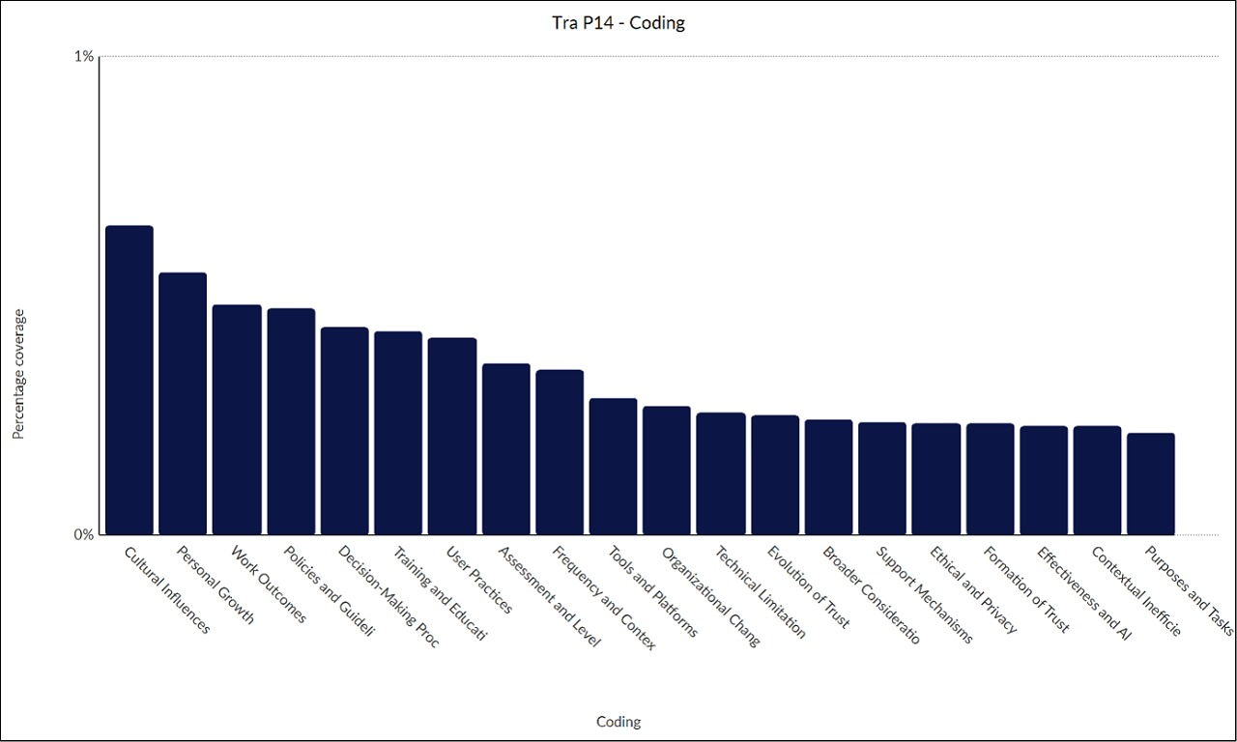
Figure 16: Transcript Participant 14 Coding

Conclusion
In general, it can be said that the themes portray AI as a potentially useful but imperfect instrument, whose credibility depends on protection. Trends indicate a changing adoption, which calls for a moderate adoption of ethically productive integration.
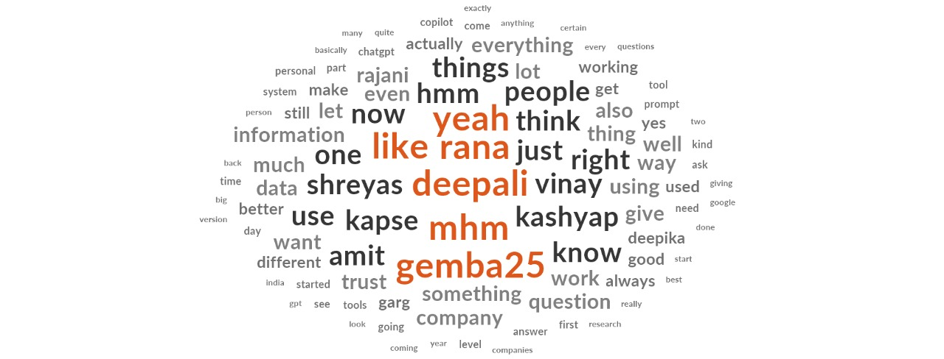
Figure 17: Wordcloud

References
Huang, L., Yu, W., Ma, W., Zhong, W., Feng, Z., Wang, H., Chen, Q., Peng, W., Feng, X., Qin, B., and Liu, T., 2023. A Survey on Hallucination in Large Language Models: Principles, Taxonomy, Challenges, and Open Questions. arXiv. [online] https://doi.org/10.48550/ARXIV.2311.05232.
Lucas, G.M., Becerik-Gerber, B. and Roll, S.C., 2024. Calibrating workers’ trust in intelligent automated systems. Patterns, [online] 5(9), p.101045. https://doi.org/10.1016/j.patter.2024.101045.
Nguyen, T. and Elbanna, A., 2025. Understanding Human-AI Augmentation in the Workplace: A Review and a Future Research Agenda. Information Systems Frontiers. [online] https://doi.org/10.1007/s10796-025-10591-5.
Wischnewski, M., Krämer, N. and Müller, E., 2023. Measuring and Understanding Trust Calibrations for Automated Systems: A Survey of the State-of-the-Art and Future Directions. Proceedings of the 2023 CHI Conference on Human Factors in Computing Systems, https://doi.org/10.1145/3544548.3581197.
Zeng, J., Chen, K., Wang, R., Li, Y., Fan, M., Wu, K., Qi, X., and Wang, L., 2025. ContractMind: Trust-calibration interaction design for AI contract review tools. International Journal of Human-Computer Studies, [online] 196, p.103411. https://doi.org/10.1016/j.ijhcs.2024.103411.

