AI-BASED REAL-TIME CONGESTION DETECTION AND DYNAMIC ROUTE OPTIMIZATIONS IN 5G NETWORKS

Abstract
As the number of connected devices and Internet of Things (IoT) applications, edge computing and autonomous systems and systems that require low latency have proliferated, so has an increased need for intelligent traffic management. With an increased installation of 5th generation (5G) communication networks, there's a growing need for intelligent traffic management, due to the advent of connected devices, Internet of Things (IoT) applications, edge computing, autonomous systems and systems that require low latency. Congestion control and routing protocols are typically not well suited to handle the highly dynamic nature of traffic, leading to higher latency, packet drop, inefficient bandwidth use and poor Quality of Service (QoS). In this study, an Artificial Intelligence (AI) based framework is presented for real-time congestion detection and dynamic routing optimisation in 5G communication networks. The framework incorporates techniques like machine learning, deep learning, clustering, and graph-based routing, enhancing network performance and traffic management.
This study employed a dataset (iwib5gnet_v1.csv) comprising of ~1000 observations of network traffic and several features related to network traffic. Data preprocessing involved feature selection, handling missing values, normalisation and temporal sequence generation for temporal analysis. The classification of the congestion was implemented using a Random Forest classifier (RFC), and the graph model, which learns the temporal traffic patterns, was implemented by using a Long Short-Term Memory (LSTM) model to predict congestion behaviour. The anomaly detection using LSTM Autoencoder and congestion severity analysis was performed employing cluster K-Means approach, which divided the traffic into four groups: LOW, MEDIUM, HIGH, and SEVERE. Moreover, a graph-based approach to optimize routing based on Dijkstra algorithm was developed to find communication paths which are congested.
The results of the experiments showed that the overall classification accuracy of the Random Forest model was 98% which provided good congestion detection capability. The outstanding performance of the LSTM in capturing the temporal dependencies of traffic and the satisfactory performance of the Autoencoder in terms of abnormal traffic detection via reconstruction error analysis was noticed. The results of clustering showed good separation between the levels of congestion. Overall, the routing optimisation framework always performed better in terms of latency than the conventional shortest hop routing algorithms through dynamic avoidance of congestion in the network. In summary, the proposed AI-based system proved to be effective in increasing the reliability, alleviating congestion, optimizing routing, and meeting QoS demands of 5G communication systems, thereby establishing a step towards advanced network management and self-provisioning.
Table of Contents
CHAPTER 1: INTRODUCTION 7
1.1 Background 7
1.2 Problem Statement 9
1.3 Objectives 10
CHAPTER 2: SIGNIFICANCE AND APPLICATIONS 12
CHAPTER 3: DETAILS OF METHOD USED 16
3.1 Data Collection and Preparation 16
3.2 Model Selection 19
3.3 How Models Work (Conceptual Equations) 22
3.4 Model Deployment 24
CHAPTER 4: Experimental Evaluation Methodology 30
4.1 Metrics 31
4.1.1 Classification Metrics 31
4.1.2 Confusion Matrix 32
4.1.3 Clustering Evaluation Metrics 33
4.1.4 Routing Optimization Metrics 34
4.2 Overfitting Analysis 34
4.3 Confusion Matrix Detailed per Class 36
CHAPTER 5: RESULTS 38
5.1 Performance 38
5.1.1 Random Forest Classification Performance 38
5.1.2 LSTM Temporal Prediction Performance 39
5.1.3 LSTM Autoencoder + K-Means Clustering Results 39
5.1.4 Dynamic Routing Optimisation Results 40
5.2 Confusion Matrix 41
5.3 Visualisations 43
CHAPTER 6: DISCUSSION 54
CHAPTER 7: CONCLUSION 58
REFERENCES 61

List of Figures
Figure 2.1: 5G Edge Architecture Diagram 13
Figure 4.2.1: LSTM Architecture 21
Figure 4.4.1: Network Diagram 26
Figure 5.2.1: Confusion Matrix 42
Figure 6.3.1: Random forest feature 43
Figure 6.3.2: Reconstruction error over time 44
Figure 6.3.3: LSTM reconstruction error heatmap 46
Figure 6.3.4: LSTM latent space 47
Figure 6.3.5: LSTM-based congestion levels 49
Figure 6.3.6: Dynamic route optimisation 50
Figure 6.3.7: Latency savings over simulation steps 52

CHAPTER 1: INTRODUCTION

1.1 Background
Incorporation of fifth-generation wireless communications technology has revolutionised contemporary digital communication systems owing to ultra-low latency, speed and massive device interconnectivity through the networks. Applications such as autonomous cars, smart healthcare, IoTs, augmented reality and smart cities have become dependent upon the effective functioning of 5G networks (Chandra Bikkasani, 2024). The problem of congestion arising from traffic and network density has become critical in today’s networks, leading to packet loss, increased latency, reduced bandwidth and poor Quality of Service (QoS) (Umar et al., 2023). Traditional routing methods, especially static shortest path algorithms fail to cope with rapidly changing network conditions (Bhattacharjee, 2025). Development of Artificial Intelligence (AI) and Machine Learning (ML) methodologies have brought forward intelligent approaches for predicting and managing traffic flow, congestion control and dynamic resource allocation in new-generation networks (Saxena, 2025). Some of these include techniques of Long Short-Term Memory, Reinforcement Learning and routing optimization with the help of deep learning (Tshakwanda et al., 2024). Hence, this study seeks to analyse an AI-based real-time congestion detection and dynamic route optimisation framework for 5G networks to enhance routing efficiency and reduce latency while improving overall network reliability and QoS.
The deployment of 5G wireless communication is a significant advancement in today’s telecommunication technology, featuring extremely high data speed, low latency, higher spectral efficiency and massive device connectivity. As a contrast with the preceding technology generations, 5G networks are expected to be able to facilitate advanced applications including autonomous transportation systems, industrial automation, augmented reality, virtual reality, smart healthcare, cloud computing and large-scale internet of things (IoT) ecosystems (Chandra Bikkasani, 2024). With the growth of these technologies, network traffic has grown exponentially and put a strain on communication infrastructures. The key goals of the 5G networks are to offer all three services of Ultra-Reliable Low-Latency Communication (URLLC), enhanced Mobile Broadband (eMBB) and massive Machine-Type Communication (mMTC) at the same time (Chandra Bikkasani, 2024). Although it has become more challenging to meet these requirements with the growing dynamics of traffic, increasing density of networks and the explosive growth of connected devices. However, congestion, packet dropping, bandwidth limitations, resource competition and poor QoS with network reliability may arise from the abundance of edge computing nodes and IoT devices (Chabira et al., 2025).
Congestion in a communication network takes place when the arrival rate of the traffic exceeds network capacity, resulting in higher latency, buffer overflow, retransmission, packet dropping and low throughput (Umar et al., 2023). The key issue with network congestion is that it becomes much more vital in terms of 5G and IoT communication, as current generation applications require immediate reaction and uninterrupted communications. For instance, applications related to autonomous vehicles, industrial robots and emergency services depend largely on real-time connectivity. This means that any network delays and misrouting could greatly affect its function. The most widely used network routing protocols rely on static rules and static heuristics such as BGP (Border Gateway Protocol), OSPF (Open Shortest Path First) and traditional shortest path routing algorithms (Bhattacharjee, 2025). Even though these approaches work in older communication generations, they cannot be applied to the new generation due to the dynamic nature of traffic generation. Classical routing strategies are reactive by nature instead of proactive, which means they respond to network congestion only after it negatively affects communication performance (Oleiwi, 2025). These techniques consequently generate nonproductive traffic distribution, recovery times and bandwidth usage. Artificial Intelligence (AI) and Machine Learning (ML) technologies have been the emerging solutions to make networks more efficient in their management and optimisation to overcome these before identifying drawbacks. Network traffic data can be extensively analysed, traffic patterns can be recognised, congestion can be predicted and resources can be optimised in real-time using artificial intelligence solutions (Saxena, 2025). Analysing network traffic data, recognizing traffic patterns, predicting congestion and optimising resources can be done through the use of artificial intelligence solutions (Saxena, 2025). Among these, AI approaches including Random Forest, CNN, LSTM and Reinforcement Learning models have gained much popularity in traffic management, anomaly detection, adaptive routing and congestion management (Bhattacharjee, 2025).
LSTM models exhibit a particular ability in capturing both long-term and short-term dependencies of network traffic patterns. Therefore, these models are appropriate for analysing sequential, time-series network traffic data and predicting future traffic patterns (Tshakwanda et al., 2024). LSTM-based predictive models would allow predicting congestion before they occur, based on the network states of future periods. Likewise, reinforcement learning-based adaptive routing systems allow continuous adaptation to network environments to make optimal routing decisions according to requirements in real-time (Tshakwanda et al., 2024). Tools for intelligent load balancing and traffic engineering optimize traffic distribution to avoid traffic congestion and ensure high QoS (Chabira et al., 2025). Edge computing is another crucial characteristic of 5G since it helps analyze data locally, thereby improving latency and real-time decision-making abilities (Saxena, 2025). Integrating AI with edge computing enables efficient traffic data analysis at network edges as well as activation of congestion mitigation measures and optimised routing policies instantly. The integration is desirable for delay-sensitive applications in the dynamic 5G ecosystem. With these developments, this research aims to analyse an AI-based congestion detection and Dynamic Routing Optimization framework in 5G Networks in real-time. The study seeks to analyse a machine learning model for congestion prediction with the graph-based routing optimisation technique to reduce latency, optimise the routing and enhance the network performance.

1.2 Problem Statement
The rapidly developing 5G and beyond wireless communication networks have dramatically added to the complexity of network management, as the number of devices connected, the deployment of networks and traffic patterns change exponentially. The future of 5G infrastructure promises a wide range of applications, including autonomous vehicles, smart cities, industrial automation, virtual realit and the Internet of Things (IoT) ecosystems, which require ultra-low latency, high reliability, and seamless connectivity (Sayed, 2025). Although with the growing need for real-time data transmission, network congestion, packet loss, routing inefficiency and Quality of Service (QoS) degradation have grown in communication networks. Most existing network management and routing techniques rely on fixed configuration, static heuristic and reactive (congestion) control. The traditional methods are becoming less effective for managing the complexities, dynamics and diversity of today’s 5G systems (James Okeda, 2025). While traditional shortest-path routing methods have successfully connected a large number of nodes, they are unable to adjust efficiently to rapidly changing traffic conditions, which leads to increased latency, poor bandwidth use, delayed recovery and inefficient traffic distribution (Jiang et al., 2024). Also, the congestion management approaches employed in the current systems usually take action only during congestion which is not conducive to proactive optimisation and intelligent resource management.
Traffic routing and congestion control issues become more complicated due to emerging issues like constant handover, load imbalance, mobility management challenges and network instability issues in ultra-dense 5G and future 6G cellular networks (Chabira et al., 2025). Furthermore, network architectures like FANETs and edge computing are prone to topology changes, link failure and resource constraints where these characteristics make traffic routing and network performance less reliable (Khan et al., 2022). The limitations make it important to deploy intelligent and adaptive approaches for traffic routing and network performance issues as they can accommodate any change in the environment. AI and ML techniques are known for having predictive analysis capability, dynamic resource management, traffic engineering, and autonomous network management skills (Sayed, 2025). These AI methods such as LSTM models, reinforcement learning algorithms and graph optimisations allow traffic networks to predict and manage traffic congestion (Tshakwanda et al., 2024). However, there remains limited comprehensive investigation into the integration of real-time congestion detection with dynamic route optimisation specifically within 5G edge-network environments despite the growing body of research in AI-enabled networking. In this context, the key gap that is addressed in this dissertation is the lack of intelligent and adaptive solutions for congestion and routing optimisation in dynamic 5G networks. This study aims to critically review the state of the art of congestion detection and dynamic routing optimisation approaches using AI to assess their performance in terms of how well they can enhance network performance, delay, packet loss and quality of service (QoS) in modern communication infrastructures.

1.3 Objectives
Research Objectives
- To analyse the key causes and consequences of network congestion in 5G communication environments.
- To assess the performance of AI and Machine Learning methods for detecting congestion in real-time 5G networks.
- To study the role of dynamic routing optimisation techniques to minimise latency, packet loss and traffic congestion of 5G networks.
- To understand the role of AI-based routing and network congestion management in enhancing overall network performance and QoS in 5G edge computing environments.
Research Aim
This study aims to critically analyse the role of Artificial Intelligence (AI) based real-time congestion detection and dynamic route optimisation techniques in enhancing the performance, efficiency and Quality of Service (QoS) of 5G communication networks.
Research Questions
- What are the key causes and consequences for congestion in 5G communication networks?
- What is the effectiveness of AI and Machine Learning methods to detect real-time congestion in 5G networks?
- Which techniques are used for dynamic routing optimisation and how do they help in minimising the latency, loss and congestion in 5G environments?
- What are the benefits of congestion detection and routing optimisation methods based on Artificial Intelligence (AI) for network performance and Quality of Service (QoS) in 5G edge networks?

CHAPTER 2: SIGNIFICANCE AND APPLICATIONS
The development of 5G networks has created novel requirements for ultra-low latency, high bandwidth, massive connectivity, and intelligent network traffic management. Conventional approaches to routing and network traffic congestion management are now proving themselves increasingly inadequate when managing the large volume of traffic that can be managed through Software Defined Networks (SDNs) (Olufemi et al., 2025). This is where this approach of using AI to create a real-time network traffic congestion and route optimisation system comes into play. This not only has relevance in the realms of industrial and academic sectors but also society as a whole and future 6G networks. One of the primary industrial applications of this framework comes from its utility in modern telecom networking and edge computing infrastructures. Modern telecommunication networks feature distributed edge nodes, network virtualisation with virtual network functions, OVS network infrastructure, and controllers that constantly analyse vast amounts of network traffic (Gonzalez et al., 2023). For such systems, instances of congestion may significantly affect QoS performance, packet latency, and transmission efficiency. Our framework facilitates intelligent identification of traffic bottlenecks by means of classification using Random Forests, time series analysis using Long Short-Term Memory, and detection of anomalies with LSTM autoencoders. Moreover, integration of this approach with dynamic routing optimisation allows the system to automatically adjust network routes in response to traffic congestion. This ability proves especially helpful in edge IaaS architecture with constantly exchanging traffic between distributed edge compute nodes using VXLAN and GTP encapsulation protocols (Saeed et al., 2024). The operational structure of the proposed AI-enabled 5G framework is illustrated in Figure 2.1. The figure additionally highlights the use of VXLAN and GTP encapsulation mechanisms together with dynamic routing optimisation and intelligent congestion detection modules integrated into the edge network infrastructure.
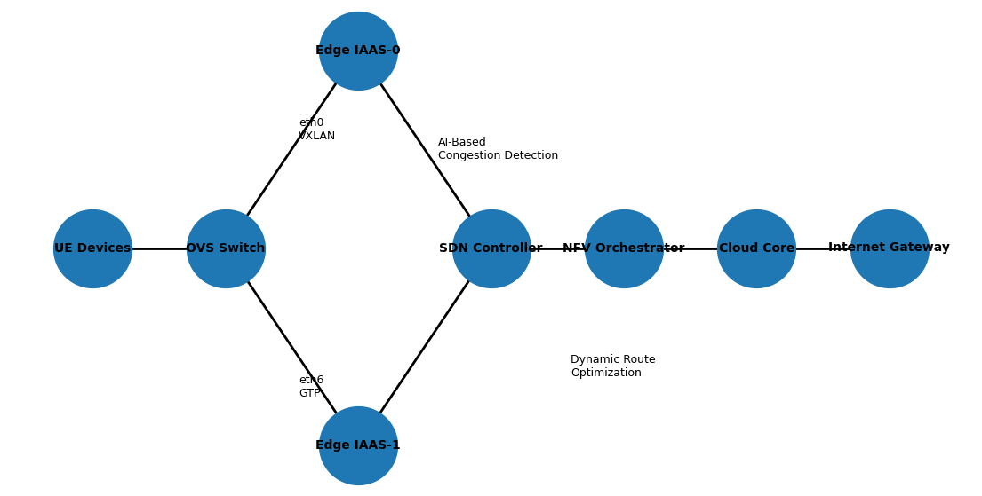

Figure 2.1: 5G Edge Architecture Diagram
(Source: self-developed)
The framework is also relevant for an autonomous vehicle communication system. Autonomous transportation environments rely heavily on ultra-reliable low-latency communication (URLLC) for vehicle-to-vehicle (V2V) and vehicle-to-infrastructure (V2I) data exchange (Singh et al., 2024). Delayed packet delivery or network congestion can directly affect the navigation and safety-critical decision-making processes. The proposed AI-based routing framework lowers the congestion-related latency by dynamically selecting optimised communication paths through Dijkstra routing. The rapid expansion of Internet of Things (IoT) devices and smart city infrastructures further increases the importance of intelligent congestion management. Smart city environments generate huge amounts of heterogeneous traffic from sensors, surveillance systems, environmental monitoring devices, and intelligent public services. Conventional static routing approaches are unable to adapt effectively to continuously fluctuating traffic conditions (Bikkasani, 2024). Existing congestion studies focus on either machine learning-based prediction or routing optimisation independently. This framework integrates multiple AI techniques such as Random Forest classification, LSTM sequential learning, LSTM Autoencoder anomaly detection, PCA-based latent feature extraction, and K-Means clustering with graph-routing optimisation. This multi-layered architecture improves both prediction accuracy and adaptive routing performance. The proposed framework also contributes academically through its use of unsupervised learning for congestion severity analysis. This allows the framework to move beyond simple binary congestion classification and provide more granular traffic condition analysis. This also supports more intelligent traffic engineering decisions within SDN-enabled communication systems. Emergency response systems can also benefit significantly from adaptive congestion-aware routing. Communication networks often experience sudden traffic surges and abnormal traffic conditions during an emergency. Static routing mechanisms may become overloaded that leads to packet loss and delayed communication. The proposed framework dynamically identifies congested network regions and reroutes traffic through lower-cost communication paths. The architecture is also applicable to future enhancements in SDN controllers and NFV orchestration systems (Ordóñez, 2022). SDN architecture isolates the control plane and data plane to enable programmable traffic management and routing control (Brito et al., 2023). The AI-based congestion prediction algorithm developed here can be incorporated directly into SDN controllers to facilitate intelligent decision-making on routing and traffic optimisation according to live network conditions. Likewise, NFV orchestration systems can make use of congestion analysis to optimise virtual network function deployments and traffic management over cloud edge systems. Additionally, the architecture has applications to future sixth-generation (6G) communication systems. Future 6G networks can operate within an ultra-dense network environment, incorporate AI-native networks, allow holographic communication, and involve autonomous intelligent systems. This would necessitate intelligent and adaptive traffic management frameworks that can cope with dynamic network conditions. The combination of AI-based congestion prediction with graph optimisation algorithms illustrated above lays the foundation for future 6G traffic engineering systems. There is a comparative analysis conducted among conventional static routing and intelligent dynamic routing as shown in Table 2.1. The analysis reveals that dynamic routing allows for more effective management of congestion, latency reduction, greater scalability, and enhanced QoS management than conventional routing methods.
Parameter | Static Routing | Dynamic AI-Based Routing
Adaptability | Fixed paths | Real-time adaptive paths
Congestion Handling | Limited | Intelligent congestion avoidance
Latency Optimization | Minimal | Dynamic latency reduction
Scalability | Moderate | High scalability
Traffic Awareness | Low | Real-time traffic analysis
QoS Support | Limited | Improved QoS management
Network Efficiency | Lower | Higher efficiency
Table 2.1: Comparison of static vs. dynamic routing benefits.

CHAPTER 3: DETAILS OF METHOD USED

3.1 Data Collection and Preparation
The effectiveness of Artificial Intelligence (AI)-driven congestion detection and dynamic route optimisation in 5G communications networks is greatly determined by the quality, format and formatting of the network traffic dataset. This study utilised the dataset iwib5gnet_v1.csv with about 1000 rows and about 72 network-related attributes that describe network traffic flow, the transmission of packets, congestion indicators and network level statistics (GitHub, 2024). The dataset was chosen as it offers various parameters related to traffic congestion and Quality of Service (QoS) behaviour in the 5G communication environment in modern times. Implementation and experimentation were done in Google Colab with Python libraries including Pandas, NumPy, TensorFlow, Scikit-learn, NetworkX and Matplotlib. The Colab setup also helped to train the Long Short-Term Memory (LSTM) Autoencoder with the help of GPU acceleration to work effectively. The data included a number of traffic and network performance parameters that were related to the transmission of the packets, use of bandwidth and routing behaviour. IPTAB_RX_bytes, OVS_RX_bytes, TC_RX_bytes, OVS_RX_dropped and TC_RX_dropped were also important features related to traffic. The variables helped in the analysis of the packet flow and the determination of traffic overload states in the network. Also, attributes like numberRulesActivatedTotal and complexity which are rule-based to measure the complexity of routing rules and their effect on network congestion were added. Other system-related variables like ContextSwitchesPerSecond, packetRate and flowCount provided further insight into the load of network processing and the efficiency of packet-handling. All these characteristics reflected the performance of the 5G communication environment as a whole and were able to analyse congestion efficiently.
The congestion status of the network was the target variable of this study. The TC_RX_dropped attribute was used to form a binary congestion label. When the value of TC RX dropped below zero, the sample of the traffic was considered congested (1) or it was non-congested (0). The reason behind the use of this binary classification technique is that one of the main indicators of network congestion in communication systems is the dropping of packets (Salau & Beyene, 2024). The obtained data set comprised about 415 congested samples and 585 normal traffic samples, forming a relatively balanced classification problem that can be analyzed using machine learning. The congestion label was created with the following preprocessing code,
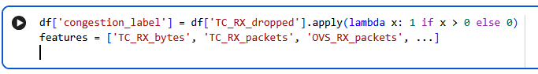
The data went through a series of preprocessing steps in order to be ready to be analysed using machine learning and deep learning to identify the congestion labels. The initial step was to load the CSV file into the Google Colab environment with the Pandas library. The dataset was further checked to determine the missing values, data types that could not be compatible and irrelevant columns. It was necessary to clean the data prior to model training since the real-world network traffic data is usually unclear and incomplete due to the failure of packet transmission and system disruption (Jiang et al., 2024). The second step entailed the selection of features. In spite of the fact that the dataset included approximately 72 attributes, not all the variables were equally significant in predicting congestion. Thus, a group of the most relevant traffic and system-level characteristics was chosen regarding their correlation with congestion behaviour. The characteristics that were chosen were TC RX bytes, TC RX packets, OVS RX packets, packet rate, flow count, context switches/second, and other indicators of traffic that were highly related to the presence of the network overload and packet dropping conditions. The dimensional complexity was also minimised with the assistance of feature selection as it minimised redundancy and enhanced model performance by eliminating irrelevant attributes in congestion. Following the selection of features, missing values in the dataset were imputed by means. The problem of missing values can adversely impact the performance of machine learning since deep learning models need full numerical input to be trained. Mean imputation was chosen since it does not affect the general statistical picture of the data, but the missing values were filled with the average values.
Another key step in the preprocessing was data scaling. The range and measurement unit of the selected network features varied which makes scaling necessary to provide uniformity when training the model. During experimentation, both StandardScaler and MinMaxScaler methods were used. StandardScaler normalised the data to a zero mean and unit variance and MinMaxScaler normalised values to the range 0-1. Scaling should be especially considered with deep learning models like LSTM since larger features (with larger numeric values) can overshadow smaller features during gradient optimisation (Zulfiqar et al., 2024). As LSTM models are aimed at sequential time-series learning, sequence preparation was done via a sliding window mechanism. A timestep value of 10 was chosen such as ten successive traffic observations were made in each input sequence. The sliding window converted the data into three-dimensional sequential data that could be used as an input in an LSTM. The resulting sequence structure was (990, 10, 10) which consisted of 990 traffic sequences of 10 timesteps and 10 chosen features. This sequence form made the LSTM model learn time dependencies and the changing behaviour of congestion with time. Exploratory Data Analysis (EDA) was done to learn about the statistical features and congestion behaviour in the dataset. To create several visualisation tools Matplotlib and Seaborn libraries were used. Another useful analysis was the distribution of TC_RX_dropped values to get insights into the behaviour of packet-dropping throughout the network. The distribution plot revealed that there were intermittent occurrence of congestion events and this implies that there were variations of traffic conditions in the simulated communication environment.
A heatmap was also used to conduct correlation analysis to determine the relationship between features. The correlation heatmap revealed that TC-related traffic characteristics which included TC_RX_packets, TC_RX_bytes and TC_RX_dropped were strongly positively correlated with congestion behaviour. This established that the measurement of packet transmission and dropping was very predictive of the congestion states. The correlation analysis was used to confirm the features chosen and prove their presence in the machine learning models. Further, the congestion level and the relationship between the packet size was analysed using scatter plots. The scatter visualisations showed that higher frequency of packet transmission and volume of packets increased the chances of congestion. These results were in line with the prior studies that indicated the connection between the overload of packets and network congestion in high-density communication system (Maftei et al., 2025). The processed sequential data was subsequently trained on the LSTM Autoencoder to provide support to the congestion clustering and anomaly analysis functions. Latent features obtained during the Autoencoder were also visualised by Principal Component Analysis (PCA) to discover latent clusters of congestion in the traffic data. The obtained labeled data of congestion clusters and severity levels was stored in a data file with clusters.csv to be used in the future to optimise the routes and manage the traffic dynamically. In general, the data gathering and preparation exercise presented a systematic and viable guideline in adopting AI-based congestion detection in 5G communication systems. Data cleaning, feature selection, scaling and sequence generation and exploratory analysis made sure that the data was prepared to be used by the machine learning, deep learning and the graph-based routing optimisation methods. These preprocessing steps formed the basis of proper prediction of congestion and smart dynamic routing in the suggested AI-based 5G network.

3.2 Model Selection
The choice of appropriate Artificial Intelligence (AI) and Machine Learning (ML) models is crucial to attain perfect congestion detection and dynamic route optimisation in a 5G communication network. Frequently, traditional routing and prediction methods fail to manage real-time traffic congestion as 5G systems produce large amounts of sequential and dynamic traffic data (Lykakis et al., 2025). Therefore, in this study, a hybrid AI architecture consisting of Random Forest Classifier, Long Short-Term Memory (LSTM) neural network, LSTM Autoencoder with K-Means and a graph-based dynamic routing optimiser based on NetworkX was used. These models were chosen due to their capability to understand the complicated traffic patterns, forecast congestion behaviour and assist with intelligent routing choices in the dynamic 5G environments. Random Forest Classifier was the first model that was chosen in this research. Random Forest is an ensemble machine learning tool that is used to combine various decision trees to achieve a better classification and minimise overfitting. The algorithm was chosen due to its strength, the capacity to deal with non-linear relationships and the capacity to establish the significance of features in the network traffic datasets. Traffic features can be extremely complex and non-linear in terms of their interactions in congestion prediction problems. Random Forest can be used to easily capture such relationships without excessive tuning of the parameters.
The scaled network traffic features of the iwib5gnet_v1.csv dataset were used to train the Random Forest model. The data set was divided into training and testing sets, and the training and testing was done with an 80/20 split, where there were an equal number of congestion and non-congestion samples in each set. Stratified sampling was used to make sure that the model learned equally under congested and normal traffic conditions. The Random Forest classifier was then used to analyse the traffic-related features such as packets, dropped packets and bandwidth signs for congestion classification. Random Forest has feature importance analysis as one of its key advantages. The algorithm determines the most influential variables that contribute to the identification of congestion, enhances interpretability and makes decisions on network management. Past research demonstrated that ensemble learning algorithms such as the Random Forest are highly accurate in the tasks of anomaly detection and predicting congestion due to their ability to manage large-scale datasets of communication in a cost-effective manner (Khattab et al., 2025). Also, the computational complexity of Random Forests models is lower than in deep learning models due to this they can be used in baseline congestion classification tasks. Random Forest yields good classification performance but it is not able to entirely describe the temporal relationship of the network behaviour. A Long Short-Term Memory (LSTM) neural network model of sequential traffic analysis was also used in this study. It is a special kind of Recurrent Neural Network (RNN) architecture that is mainly used to process time-series data and maintain the long-term dependencies by gating mechanisms. LSTM models are the best choice to examine sequential network behaviour as congestion is a dynamic phenomenon (Deng, 2025). The LSTM architecture used was two layers of LSTMs with a dense output layer, and the initial LSTM layer had 50 units return sequence is equal to True. A Dropout layer was inserted after the initial LSTM layer to minimise the effect of overfitting through randomly shutting down neurons during training (Mahjoub et al., 2022). The second LSTM layer had also 50 units, and this was followed by a Dense layer with a sigmoid activation function to predict binary congestion. The LSTM model learned sequential traffic dependencies from the generated traffic sequences with a timestamp size equal to 10. LSTM models provide better predictive performance for dynamic communication systems as compared to static machine learning algorithms.
This study also implemented an LSTM Autoencoder that was combined with K-Means clustering for unsupervised congestion analysis. This type of encoder is selected because it performs feature compression, latent traffic representation, and anomaly detection simultaneously. Autoencoders do not require manually labelled congestion data that make them suitable for real-time network environments where labelled datasets can be limited (Mobtahej et al., 2022). The Autoencoder architecture compressed traffic sequences into lower-dimensional latent vectors using an LSTM layer with 64 hidden units and a bottleneck dense layer. The decoder reconstructed the original sequences from the compressed representations. Reconstruction error analysis was then used to recognise congestion anomalies within the network traffic data. After extracting latent features from the encoder K-Means clustering was applied to group traffic behaviour into four congestion severity clusters that are LOW, MEDIUM, HIGH and SEVERE. The clustering process improved congestion interpretation and enabled severity-based routing optimisation. Principal Component Analysis (PCA) was also used to visualise latent congestion clusters within a two-dimensional feature space (Nashaat et al., 2024). This study adopted a graph-based routing framework that was implemented using the NetworkX library. The graph theory-based optimisation techniques are highly effective for adaptive routing applications. The routing optimiser used synthetic and live congestion severity values generated from the K-means clustering framework and LSTM Autoencoder. The study also compares two routing strategies that are Breadth-First Search (BFS) and Dijkstra’s shortest path algorithm (Boubaker et al., 2025; Yang et al., 2025). BFS selects the path with the fewest hops regardless of congestion conditions, and Dijkstra’s algorithm considers weighted congestion costs during path optimisation. The comparison had shown that the congestion-aware Dijkstra routing method had lower congestion cost with better distribution of traffic than the traditional shortest-hops routing methods. The models assisted each other in achieving high QoS, reducing congestion, and optimizing routing in the envisioned 5G AI network.
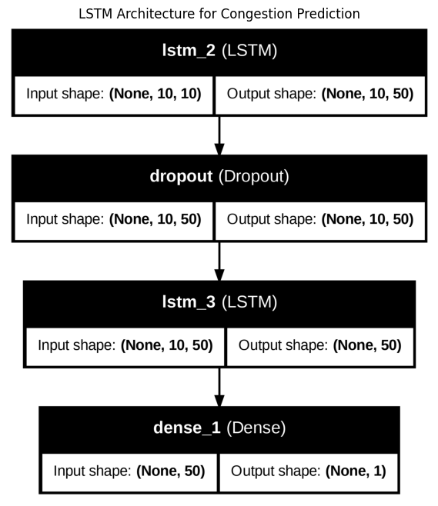

Figure 4.2.1: LSTM Architecture
(Source: self-developed)

3.3 How Models Work (Conceptual Equations)
The AI-based congestion detection and dynamic route optimisation framework integrates multiple Artificial Intelligence (AI), Machine Learning (ML), and graph-based optimisation models. These can contribute to the analysis of traffic behaviour and the prediction of the severity of traffic congestion and optimisation of routing decisions in 5G communication networks. The system performs random forest classification, LSTM, K-Means clustering and Dijkstra-based graph routing optimisation. Every model is relevant to the various aspects of congestion analysis and smart traffic control. Random forest is an ensemble machine learning model that uses a set of decision trees to improve classification accuracy. The selected traffic features are used to predict the congestion in the network, independently by each tree. The final prediction is obtained through majority voting among all decision trees. The random forest prediction process can be represented as follows (Nachouki et al., 2023).
Ŷ = mode (T₁(x), T₂(x), T₃(x), T₄(x), ….,T_{n}(x))
Where Ŷ represents the final predicted congestion class, Ti(x) denotes the prediction generated by the i^{th} decision tree, and n is the total number of decision trees in the forest. The model analyzes different traffic parameters like packet dropping frequency, packet transmission rate, bandwidth utilisation etc. and categorizes the traffic in terms of the congestion conditions. Feature importance is computed using Gini impurity reduction and enables the model to recognize the most significant variables when it comes to congestion. The Gini impurity is defined as below
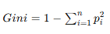
Where pi is the probability of a sample belonging to class i. Lower Gini impurity values indicate better classification purity within the decision trees (Kim et al., 2024). An LSTM neural network was chosen due to its capability of capturing time dependency and traffic sequences. In contrast to conventional neural networks, an LSTM network is composed of memory cells and gates through which it is able to retain short and long-term traffic records. The core operation of the LSTM cell includes the forget gate, input gate, and output gate. The forget gate evaluates the previous information that needs to be discarded from the cell memory.
ft = σ (W_{f} [h_{t-1}, x_{t}] + b_{f})
Where ft is the forget gate output, xt is the current output, and h_{t-1} is known as the previous hidden state. The input gate controls which new information should be added to the cell state.
f_{t} = σ (W_{i} [h_{i-1}, x_{t}] + b_{i})
The cell memory is updated using both the forget and input gates.
Where ct is the updated cell state, ct is referred to as candidate memory values, and ⊙ denotes the element-wise multiplication. The output gate determines the hidden output of the LSTM cell.
The LSTM model learns the traffic behavior over time and forecasts the traffic state in the future from the history of the traffic observation. LSTM Autoencoder is a neural network model which belongs to the unsupervised deep learning methods (Lachekhab et al., 2024). This approach is based on learning features in latent space using an Autoencoder composed of a traffic anomaly detection encoder and a decoder. The encoder transformation is represented as z = encoder (x). The decoder reconstructs the sequence using Ŷ = Decoder(z). The reconstruction error measures the difference between the original and reconstructed sequences:
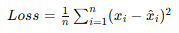
The K-Means clustering technique was employed for grouping the traffic data into different levels of congestion. The clustering algorithm divides the traffic sample into various groups such that the distance between the point and the cluster is minimised.
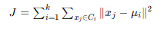
Where k represents the number of clusters, Ci​ denotes cluster i, μi​ is the centroid of cluster i, and xj​ represents traffic samples within the cluster. To visually analyse the latent traffic features extracted from the LSTM Autoencoder, PCA was employed for the purpose. Due to the latent traffic feature vectors being high-dimensional in nature, PCA helped reduce the dimensionality of the traffic features while retaining the highest possible variance within the data. This approach allowed effective visual analysis of congestion patterns as well as traffic clusters that were formed. Using the PCA technique, it was found that separation between normal and congested traffic was possible. Thus, the effectiveness of clustering done in the congestion detection model was validated. The PCA transformation is represented as:
Z = XW
Where X is known as the original feature matrix, and W is referred to as the projection matrix. For Dynamic Route Optimisation, a shortest path routing algorithm called the Dijkstra algorithm has been adopted using NetworkX graphs. For the NetworkX graph, communication devices form the nodes, while the edges in the graph are the communication links between those nodes (Cruz et al., 2025). Weights are assigned to each communication link based on the transmission cost of each and the extent of congestion on it. Unlike traditional shortest-hop routing, the proposed approach dynamically avoided congested network paths by increasing the cost of overloaded links. This enabled intelligent traffic distribution, reduced packet dropping and improved Quality of Service (QoS) within the 5G communication environment (Khan, 2022).
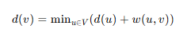
Where d(v) is referred to as the shortest distance to node v, w(u, v) represents the edge weight between nodes u and v, and V denotes the set of nodes in the graph.

3.4 Model Deployment
Gradio Dashboard: Live Graph, Latency Charts, Heatmap, and Re-route Alerts
In order to build and implement the 5G Dynamic Route Optimizer, the Gradio framework, powered by Python, was used to create an interactive and real-time visualisation environment for congestion-aware routing analysis. The dashboard serves as the user interface for the machine learning models and network optimisation engine. It constantly visualises congestion prediction based on the LSTM-based framework and dynamically modifies the network topology based on the simulation of traffic. There are several visualisation elements of the interface. The first component is the congestion prediction graph, which is built using an LSTM model, showcasing congestion plotted at each time step. Moderate and severe congestion markers are added to threshold markers. This visualisation will help users see the traffic fluctuations occurring across time and anomalies in network usage. The second component includes the graph visualisation based on NetworkX of the edge network Topology of 5G networks. The nodes are assigned colors based on the congestion level, with green signifying less congestion, orange signifying moderate congestion, and red signifying high congestion. Here, the optimal route discovered by Dijkstra's algorithm is highlighted in blue. Other dashboard features include automated congestion heat maps, latency comparison charts, and automated probes re-route alerts. The latency charts show differences between traditional shortest-hop and congestion-aware optimal routing to highlight performance improvements. Re-route notifications are activated when the weighted optimal path begins to deviate from the default shortest route because of more or more severe congestion. Additionally, the Gradio deployment can accept periodic restarts based on the demo.load(..., every=5) argument, which makes it possible to update network parameters and routing decisions nearly in real-time while observing them in Gradio.
Simulation Loop: SimState(), Tick(), and Path Comparison
A continuous simulation mechanism is embedded in the deployment architecture, which can simulate the congestion behaviors under a 5G edge network environment (Rahimi et al., 2021). The simulation loop creates evolving networks, updates congestion values, re-computes the weight of the edges, and assesses decisions regarding the routes at each iteration. In this iterative process, realistic variations of traffic intensity and packet transmission conditions across interconnected edge nodes can be modelled in the system. Conceptually, the simulation framework is implemented by using a structure similar to SimState(), with each iteration being a discrete network monitoring cycle. A tick() function updates the operating parameters of the network simulation, such as node congestion levels, characteristics of the packet flow, and the expectation of traffic severity. Randomised congestion values are generated, followed by LSTM-generated prediction values, which simulate the future congestion probabilities, in order to emulate changing network conditions. The values are then used to weight graph edges as costs.
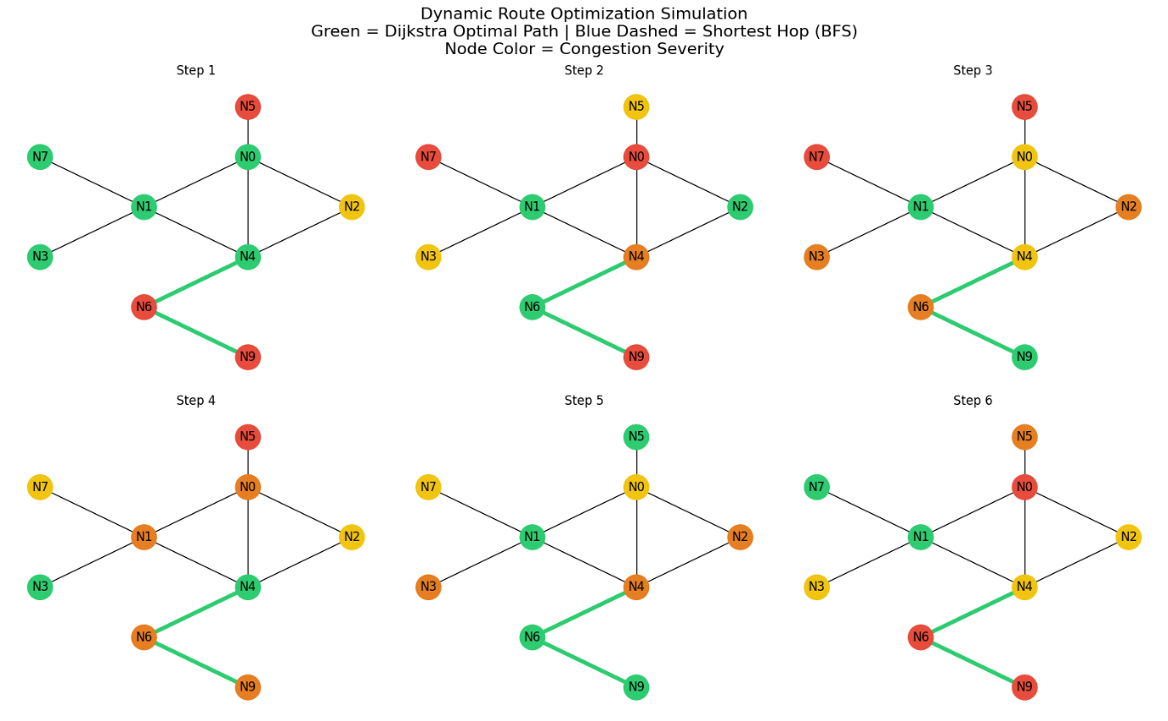

Figure 4.4.1: Network Diagram
(Source: Python)
As per the state update, two routing strategies are compared. For the first strategy, the shortest-path routing is considered, avoiding congestion awareness, while the second applied congestion-weighted edges in accordance with Dijkstra's algorithm. This comparison takes into account the differences in route efficiency, costs, and congestion exposure. A separate path_cost() function is used to calculate the cumulative congestion cost of each selected path by taking the average congestion level between the two link sizes. Also, the simulation loop determines percentages of routing improvement that give quantitative benefits of optimisation due to dynamic re-routing. The system illustrates the adaptive ability of congestion-aware routing in response to shifting network conditions by repeating the cycle several times. Thus, the results from the iterative simulation validate the responsiveness, scalability, and operational effectiveness of the proposed intelligent routing framework.
Artifacts: Scaler, Encoder, and K-Means (lstm_cluster_artifacts)
Several machine learning products were created and stored during the training of the model to ensure repeatability and effective delivery of the intelligent routing architecture. The pre-processing objects, trained neural network components, and clustering models are packaged collaboratively as lstm_cluster_artifacts, which are used for real-time congestion severity prediction. Retention of these artifacts avoids the necessity of re-training upon deployment and fast inference within the live routing system. The first major artifact is the feature scaler, which can be created by employing StandardScaler or MinMaxScaler (Priyambudi & Nugroho, 2024). The numerical ranges for different network traffic features, such as TC_RX_bytes, OVS_RX_packets, and packetRate, make normalisation crucial for stable model learning. Scaler artifact effectively preserves the statistical transformation parameters in the training phase and guarantees the data will be consistently processed before an inference. The second artifact is the trained model of the LSTM Autoencoder (Simpson et al., 2021). The encoder part plays a fundamental role in extracting high latent representations from sequences of high-dimensional compressed traffic data that are compressed. These latent features reflect the temporal evolution of the traffic, traffic congestion, and hidden correlations between network parameters. These encoded representations are then used for clustering and analysing congestion severity. The third artifact is the K-means clustering model for congestion categorisation (Alshawki et al., 2024). The clustering algorithm classifies traffic into four different congestion severity levels, such as LOW, MEDIUM, HIGH, and SEVERE congestion, after training on encoded latent vectors. These cluster labels are further used in the graph re-weighting to determine the routing penalties. Therefore, these deployment artifacts result in an end-to-end inference pipeline that encodes the scaled traffic data, clusters based on the traffic data, maps to their severities, and finally generates the dynamic edge weights for congestion-based route optimisation in the 5G edge network.
The system integrated congestion severity prediction, dynamic graph re-weighting and intelligent route selection into a cohesive deployment ecosystem that can now analyse traffic patterns and automatically optimise communication routes. This deployment process has been created with Python through the Google Colab environment and the addition of TensorFlow, Scikit-learn, NetworkX, Streamlit and visualisation libraries. The deployment process started with the trained Autoencoder LSTM model and K-Means clustering outputting the prediction of congestion level from real or simulated network traffic. The traffic observations collected sequentially from the network were preprocessed in the preprocessing pipeline, where they were scaled and converted to sequences. The resulting traffic sequences were then used in the LSTM Autoencoder to learn the traffic mapping and to identify abnormal traffic patterns in the network when traffic becomes congested. The extent of congestion formed the central element of the deployment process rationale. The extent of congestion became the heart of the deployment process decision-making. When congestion levels were detected, the routing optimisation module updated the dynamic communication graph based on severity information. A weighted NetworkX graph was created to represent the network topology, and nodes represent edge computing devices or communication routers, and the edges represent communication links between the nodes. Base transmission cost for each communication link was initially assigned under the normal traffic conditions (Zeng et al., 2025). If a network path was congested more, a congestion penalty was added to its initial transmission cost, and its edge weight was increased. This led to a less favourable choice of heavily congested routes for traffic transmission. This resulted in an edge-weight adjustment mechanism that the routing optimiser used for avoiding overloaded network segments, instead of waiting for large amounts of dropping and latency to begin. The edge weights were updated, and then the Dijkstra shortest path algorithm was run to find the shortest path between the source node and the destination node. The proposed deployment system is deployed based on dynamically varying traffic conditions as opposed to traditional routing approaches relying on simple shortest-hop calculations. This allowed the routing model to continually use real-time data to determine communication paths that used the shortest latency and least congested links. If the traffic became more congested on the route shown on the drawing, the optimiser would automatically rework alternative routes and reroute traffic. This process of dynamic re-routing optimised the distribution of traffic, minimised packet loss and improved the Quality of Service (QoS) in the simulated 5G environment. A Streamlit dashboard interface was added to the deployment framework to enable real-time monitoring and interaction. The dashboard gave a visualisation of the communication network, the severity distribution of the congestion and the routing behaviour. The nodes in the graph were colour-coded based on the congestion level, with the green nodes having a low congestion level and the red nodes having a severe congestion level. The interface also presented the routing information, the congestion heat images, as well as reconstruction error analysis and a latency comparison chart of various communication paths. Real-time simulation controls enabled dynamic traffic generation and congestion updates throughout the network graph also added to the deployment framework.
For each of the simulation steps, the traffic state was updated, the severity of the congestion was redetermined, and the route was re-optimised according to the network state at the moment of the simulation step. These updates were continually reported on the dashboard, demonstrating the flexibility and adaptability of the AI-powered routing system to stay on top of the ever-changing nature of communication traffic. To make the machine learning models and the pre-processing artefacts deployable and reusable, they were saved in lstm_cluster_artifacts. These artefacts included the trained scaler, encoder model, clustering model and congestion labels. By saving the components, the deployment system could load the pre-trained models during runtime without retraining new models, which meant it could save on computation and shorten the deployment time. The deployment was done on Google Colab with the help of ngrok and local tunnel services that enabled us to access the dashboard interface from the outside. This cloud deployment approach allowed remote visualisation and monitoring of the C-AR system without the need for dedicated local servers and machine infrastructure. The interaction of cloud deployment also highlighted the scalability and flexibility of the suggested framework to be potentially integrated in future real-world 5G edge computing deployments (Gómez et al., 2024). The deployment phase achieved a successful integration of the AI-based congestion prediction system with the graph-based dynamic routing optimisation system to form a comprehensive intelligent traffic management system (Purnamasari & Nurwildani, 2025). The system's ability to proactively manage network traffic and keep the communication performance efficient even with the varying traffic conditions was facilitated by the relationship between predicted congestion severity, edge-weight modification and dynamic re-routing.

CHAPTER 4: Experimental Evaluation Methodology
The experimental evaluation methodology was designed to validate the effectiveness, reliability and generalization capability of the proposed AI based congestion detection and dynamic route optimization framework for 5G edge networks. The evaluation framework has concentrated on three key aspects of the proposed system: Congestion Classification, Congestion severity estimation, and Congestion-aware routing optimization. The experiments were performed on the iwib5gnet_v1.csv dataset which includes more or less 1000 network traffic observations and over 70 features related to network traffic such as packet transmission statistics, traffic control metrics, Open vSwitch parameters, information on the activation of specific traffic control rules, and flow-based network characteristics. The proposed framework combined supervised learning, unsupervised learning and optimization techniques based on graphs. The models employed for congestion prediction were the Random Forest model and the Long Short-Term Memory (LSTM) model (Wang et al., 2020). The model used for congestion severity estimation was the LSTM Autoencoder model and K-Means clustering was used. Dijkstra's shortest path algorithm was used to perform dynamic routing optimization on weighted network graphs.
The experimental setup was designed to mimic realistic traffic fluctuations that are typical for most of the edge network scenarios in the modern 5G system. The dataset evaluation process took into account several conditions of traffic flow: normal, moderate and severe. This allowed the proposed framework to evaluate the congestion prediction and routing adaptation in dynamically changing network scenarios and varying packet transmission conditions. Dataset preprocessing, feature normalization, sequence generation, model training, validation, testing, clustering and routing simulation were included in the experimental workflow. To ensure the dataset had consistent feature distributions across the dataset, numerical feature scaling was done using StandardScaler. Missing values in the dataset were imputed using median imputation. To obtain the temporal learning in the LSTM models, the normalized traffic data was used to produce a sequence of ten timesteps of the sliding window. The dataset has been split into 80% for training and 20% for testing, according to an 80:20 split ratio. Stratified sampling techniques were used in splitting in order to maintain the original distribution of congested and non-congested traffic samples. The evaluation was performed with unseen testing data, to assess the generalization ability of the proposed models in a dynamic network environment.

4.1 Metrics
The proposed framework was tested with various performance metrics that measure the effectiveness of congestion prediction, clustering quality and routing optimization. Given that this framework combines supervised, unsupervised, and graph-based network optimization evaluation metrics were needed to provide a comprehensive system performance evaluation. The evaluation metrics were chosen to be able to perform predictive performance evaluation in addition to operational routing efficiency analysis in the proposed framework (Wang et al., 2020). The set of metrics were designed to not only assess the accuracy of classification but also the effectiveness of the routing adaptation and the severity of congestion under dynamic network conditions, given that such metrics would be correlated to latency sensitive applications and Quality of Service (QoS).

4.1.1 Classification Metrics
Random Forest and LSTM congestion prediction models were assessed through the help of Accuracy, Precision, Recall, F1 score and Confusion Matrix analysis. These metrics were chosen as they give an overall measure of classification performance as well as a measure for each class.
Accuracy
The accuracy is the percentage of the observations that were correctly classified.
$$Accuracy=\frac{TP+TN}{TP+TN+FP+FN}$$
Where:
- TP = True Positives
- TN = True Negatives
- FP = False Positives
- FN = False Negatives
The ability of the congestion classification models to predict the overall congestion was assessed using accuracy.
Precision
Precision is the ratio of correctly predicted congestion samples to the total number of samples that are predicted as congestion.
$$Precision=\frac{TP}{TP+FP}$$
Precision was added to assess the reliability of the congestion predictions that were made by the classification framework.
Recall
Recall is the percentage of the real congestion samples that are correctly predicted by the predictive model.
$$Recall=\frac{TP}{TP+FN}$$
The decision to use recall was made because congestion is not known to have adverse effects on Quality of Service (QoS) and latency-sensitive applications in 5G networks.
F1-Score
F1 score is the harmonic mean of the Precision and Recall scores.
$$F1=2×\frac{Precision×Recall}{Precision+Recall}$$
To get a balanced evaluation, even under class imbalance between congested and non-congested traffic conditions, the F1-score was utilized.

4.1.2 Confusion Matrix
The confusion matrix analysis was used to assess the congestion classification models for the class-wise prediction behavior. A confusion matrix is a structured way to represent the true class and predicted class in the classification process and is useful in analyzing classification results.
The structure of confusion matrix is broken into four major elements:
- True Positives (TP)
- True Negatives (TN)
- False Positives (FP)
- False Negatives (FN)
$$[ TP FP ]$$
$$[ FN TN ]$$
The confusion matrix was created during the test stage with the help of unseen traffic samples. This matrix was also employed to calculate the metrics of Accuracy, Precision, Recall, Specificity and F1-score. The evaluation at the class level using the confusion matrix allowed a systematic study of misclassification behavior for the different traffic classes (congestion and non-congestion).

4.1.3 Clustering Evaluation Metrics
The reconstruction error analysis and latent space representation techniques were used to assess the performance of the LSTM Autoencoder and K-Means clustering framework.
Mean Squared Error (MSE)
The Mean Squared Error (MSE) was used to assess the reconstruction performance of the LSTM Autoencoder.
$$MSE=\frac{1}{n}\sum_{i=1}^{n}{(x_{i}-\hat{x_{i}})}$$
The metric used for the difference between the original traffic sequences and reconstructed sequences generated by the autoencoder network was MSE.
Latent Space Visualization
The latent feature vectors from the encoder network were used for Principal Component Analysis (PCA). PCA mapped latent representations to a 2D feature space, to facilitate cluster visualization and inspection.
Clustering Procedure
The latent feature vectors produced by the Encoder model were used for K-means clustering. The traffic observations were classified into several different congestion severity categories through the clustering process (Kouchaki et al., 2024). In the routing optimization, cluster centroids were used for mapping the severity and congestion state in the routing.

4.1.4 Routing Optimization Metrics
In graph-based simulations of networks, the routing optimization component was tested by testing its latency-oriented performance metrics.
Total Routing Cost
Congestion adjusted edge weights were used to compute a routing cost.
$$Total Cost=Base Latency+Congestion Penalty$$
The congestion penalties were dynamically assigned based on the severity level of the nodes calculated through the congestion clustering framework.
Latency Savings
Latency savings were computed by comparing the congestion aware Dijkstra routing to shortest-hop routing methods.
$$Latency Savings=BFS Cost-Dijkstra Cost$$
The routing efficiency was assessed based on this metric with dynamically varying congestion conditions assumed.
Re-routing Frequency
Re-routing frequency was defined as how many times during the simulation steps the best route changed because of the change in congestion severity conditions.

4.2 Overfitting Analysis
For the proposed machine learning models, overfitting analysis was performed to assess the generalization ability of the machine learning models, and to verify the machine learning models did not over memorize training samples. The key process of the evaluation was to keep the performance stable when presented with test data that does not appear in the training data, but to minimize dependence on patterns used in training. The data set was split into training and testing at 80:20 proportion. To ensure balanced representation of the congestion classes in both sets, stratified sampling techniques were used while splitting the datasets. This improved sampling bias and the evaluation conditions. Bootstrap aggregation (bagging) and randomized feature selection were used to prevent overfitting in the Random Forest classifier. Random subsets of the training data were used to train multiple decision trees, with final predictions made using majority voting over the decision trees. The ensemble-based structure reduced the variance and minimized dependency of individual training samples. Apart from regularization techniques, the behavior of the models was also monitored during training to guarantee stable learning performance. The batch size, learning rate, number of epochs, and dimension of the hidden layers were varied with iterations during the experiments. This tuning was required to balance predictive ability and generalization performance without creating undue complexity when performing the congestion prediction and sequence reconstruction task. The cross-validation techniques were integrated in model evaluation to ensure the stability of the models in different data partition sets (Khan et al., 2021). The validation was used to check the predictive consistency with different distributions of the datasets.
In order to minimize the risk of overfitting when learning the temporal sequences, the LSTM model used multiple regularization methods. Recurrent layers were cascaded with dropout layers in between to randomly disable neurons during training. In this way, the process minimized neuron co-adaptation and enhanced the learning performance in general for sequential traffic patterns. Additionally, earlyStopping callbacks were added when training the models. Automatic training process stopped due to lack of improvement in validation loss for more than a few epochs. This mechanism removed the superfluous optimization on the training samples and reduced the memorization effect. The training loss and validation loss curves were tracked throughout the learning process to explore the convergence behaviour during training. Any divergence patterns between these curves were used as indicators for possible overfitting conditions. LSTM Autoencoder training was performed, and similar monitoring was used with the trends of reconstruction loss. The use of feature normalization via StandardScaler helped achieve stable convergence of models through ensuring uniformity in the numerical distribution of traffic-related features (Khan et al., 2021). Sequential generation with sliding windows also ensured the temporal continuity of the signal during the training and evaluation of LSTM.

4.3 Confusion Matrix Detailed per Class
The class-wise prediction performance of the congestion classification models was assessed using the confusion matrix analysis. The confusion matrix is a tabular representation of the actual and predicted class labels, which allows us to examine the classification behavior for each traffic category in detail (Wang et al., 2020).
The assessment scheme took into account two major traffic categories:
- Non-congested traffic
- Congested traffic
The confusion matrix is divided into four components:
- True Positives (TP)
- True Negatives (TN)
- False Positives (FP)
- False Negatives (FN)
True Positives
True Positives are those samples that are classified as congested by the predictive model when they are actually congested. This component was used to assess the ability of the model to identify real congestion states in the network environment.
True Negatives
True Negatives are traffic samples that are correctly classified as non-congested. This was used to determine the ability of the model to differentiate between normal network activity and congestion-related activity.
False Positives
False Positives are when non-congested traffic is misidentified as congested traffic. This category was added so as to study the unneeded congestion predictions made by the classification framework.
False Negatives
False Negatives are when a sample of traffic is incorrectly identified as non-congested traffic. For this, the category was used to analyze missed conditions in the congestion prediction. Class-wise confusion matrix analysis was especially crucial since the congestion datasets could have imbalance between the normal and congested traffic conditions.
This classification accuracy assessment allowed for a finer-grained classification analysis of the accuracy of each classification level and the identification of any bias in the predictive model towards any specific traffic category. This analysis also helped to interpret the sensitivity of the congestion detection and the ability to discriminate network traffic in the proposed system. During the testing phase the confusion matrix was created with unseen traffic samples from the testing data set (Ramezanpour & Jagannath, 2021). The matrix was also further used to compute the Accuracy, Precision, Recall, Specificity, and F1-score metrics. Confusion matrix analysis, performed at the class level, allowed for systematic investigation of misclassifications by traffic category and for comparison of misclassifications between classification models within the proposed framework.

CHAPTER 5: RESULTS

5.1 Performance

5.1.1 Random Forest Classification Performance
Random Forest classifier exhibited superior performance in congested classification in the simulated 5G network setting. On the testing data, the model showed an overall accuracy of 98%, which meant that the model had good prediction ability for the different congestion management conditions. The classification report further revealed that the precision, recall, and F1 scores were all close to optimal values for all categories of traffic, such as IPTABLES, OVS traffic category, and others. The OVS class had 99% precision and 100% recall, showcasing the model's solid performance in recognising the traffic condition on OVS.
 | Precision | Recall | F1-score | Support
IPTABLES | 1.00 | 0.90 | 0.95 | 10
OVS | 0.99 | 1.00 | 0.99 | 171
TC | 0.94 | 0.89 | 0.92 | 19
Accuracy |  |  | 0.98 | 200
Macro avg | 0.98 | 0.93 | 0.95 | 200
Weighted avg | 0.98 | 0.98 | 0.98 | 200
In a similar way, the IPTABLES class scored an F1 of 0.95, and the TC class scored an F1 of 0.92 despite having comparatively fewer training samples. The weighted average F1-score of 0.98 showed that the classifier had a steady performance on the entire dataset. The confusion matrix also highlighted that classification error rates were low and there were no significant class imbalance problems. In general, the Random Forest model could accurately detect congestion and form a solid basis for future temporal predictions and routing optimisation in the proposed intelligent 5G congestion management framework.

5.1.2 LSTM Temporal Prediction Performance
The LSTM model was applied to study traffic behaviour sequences and to conduct a temporal congestion predictor in the simulated 5G network scenario. In contrast to conventional machine-learning models, the LSTM architecture was able to learn the long-term traffic variations and dependency relationships in time-series data from the network. The training process for the model showed consistent convergence performance, with the training loss and validation loss decreasing over time and epochs. It suggests that the model was stable and non-divergent during its learning of the congestion patterns over time. Training and validation loss curves during the generation also demonstrated the generalisation capacity of the LSTM framework during training. The model was able to reflect a clearer transition between the normal and overloaded congestion traffic transitions across than static classification of sequence-based traffic analysis. Moreover, there were evident fluctuations of temporal reconstruction error within abnormal traffic intervals, indicating model sensitivity towards the changes in traffic at intervals.
Therefore, the LSTM framework was found to be very suitable for real-time congestion forecasting for sequential traffic monitoring applications. The ability to handle ever-changing traffic patterns made a huge contribution to enhancing the intelligent prediction in the proposed 5G congestion detection and routing optimisation system using an artificial intelligence algorithm.

5.1.3 LSTM Autoencoder + K-Means Clustering Results
The results showed that the LSTM Autoencoder (AE) achieved good performance for unsupervised congestion severity analysis of the simulated 5G network environment through K-Means clustering. The autoencoder models improved sequential patterns of traffic flow in compressed latent representations using an encoding and decoding architecture. The process allowed them to extract important information regarding the hidden traffic properties while reducing the dimensionality of the original network traffic data. The reconstruction error analysis revealed a higher error during abnormal traffic conditions, verifying the ability of the model to detect abnormal traffic situations and unexpected network behavior. Latent features were extracted and further processed using the K-Means clustering algorithm to classify traffic conditions into several congestion levels. This also showed up in the Principal Component Analysis (PCA) visualisation as relatively well-separated clusters in the latent feature space, indicating that the features have been learned properly, and a good clustering behavior is observed. In addition to simply low and high traffic conditions, congestion categories were generated that contained LOW, MEDIUM, HIGH, and SEVERE.
The use of LSTM Autoencoder and K-Means clustering expanded the ability of the proposed framework for overall monitoring, with the ability to dynamically assess congestion severity and detect anomalies in the load. This helped make intelligent routing adaptation and real-time congestion management possible in modern software-defined 5G network infrastructure.

5.1.4 Dynamic Routing Optimisation Results
The dynamic routing optimisation framework was applied to test the congestion-aware path selection within the simulated software-defined 5G network environment. The routing mechanism used Dijkstra's shortest-path algorithm, along with a congestion-aware edge weighting mechanism, which assisted in dynamically selecting the best route for communication under different traffic conditions. The proposed framework was additionally compared with traditional shortest-hop routing approaches in order to evaluate the effectiveness of intelligent path adaptation during network congestion scenarios. The detailed evaluation of simulation results has shown that the proposed congestion-aware routing mechanism avoided the heavily congested nodes and diverted to other lower traffic penalty (LTP) alternative paths, which yielded reduced transmission costs. The multi-step routing simulations were also demonstrated to yield a continuous recalculation of routing whenever the congestion severity changed over the network. The visualisations of the network further supported a clear indication of node severity by using a different color according to low-to-severe congestion conditions.
The routing optimisation process also helped ensure smoother traffic distribution, generating better load-balancing on critical network segments. In several simulation cases, the congestion-aware optimal route achieved lower latency compared to the conventional shortest-hop route. Overall, the proposed dynamic routing approach demonstrates good performance in combining intelligent congestion prediction with adaptive route optimisation to enhance the Quality of Service (QoS) and network stability for modern 5G networks.

5.2 Confusion Matrix
The confusion matrix was used to comprehensively assess the random forest classifier model adopted for congestion detection in the proposed AI-driven 5G network management framework. The confusion matrix was used to analyse the performance of the prediction and differentiate between the correct and incorrect traffic samples classified per class, unlike the overall accuracy values. The generated matrix had three large classes of traffic management mechanisms, such as IPTABLES, OVS, and TC. The confusion matrix obtained was:
$$\left[\begin{matrix}9 & 0 & 1 \\ 0 & 171 & 0 \\ 0 & 2 & 17\end{matrix}\right]$$
The first row was the IPTABLES class. With 10 actual IPTABLES samples, 9 were correctly classified, while only 1 sample was incorrectly predicted into the TC class. This led to precision and recall being 1.00 and 0.90, respectively, for IPTABLES traffic. The results showed that when the model estimated the IPTABLES category, the estimated class was almost always correct. The slightly lower recall value was caused by the single misclassified sample. The second row represented the OVS traffic class, which has the highest number of samples in the data set. There were no false negatives and false positives with all 171 OVS samples being correctly classified. This gave an almost perfect classification result, with a precision of 0.99, a recall of 1.00, and an F1 score of 0.99. The results from this class showed a great performance of the Random Forest model in distinguishing characteristics of the traffic belonging to the Open vSwitch service in the traffic packets of the network environment, and the behaviour of the congestion.
The third row demonstrated the traffic class. The correct classification of 17 of 19 TC samples and the wrong prediction of 2 samples in the class OVS indicated that the classification was correct. The above-mentioned minor errors did not affect the precision value on the TC class to date, which was found to be 0.94, and the recall value was 0.89, and the F1-scores were 0.92. A lower recall rate for the OVS class might be because of the limited amount of training samples in the OVS class.
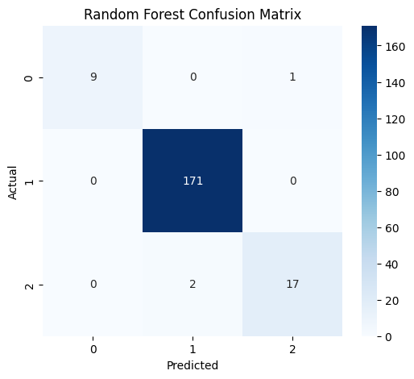

Figure 5.2.1: Confusion Matrix
(Source: Python)
The overall results of the confusion matrix indicated good classification accuracy for all traffic classes. Weighted average precision and recall values were both close to 0.98, along with the F1 score, indicating good generalisation ability and inhibiting class imbalance influences. Furthermore, it achieved extremely low misclassification proportions, especially featuring multiple traffic control mechanisms.

5.3 Visualisations
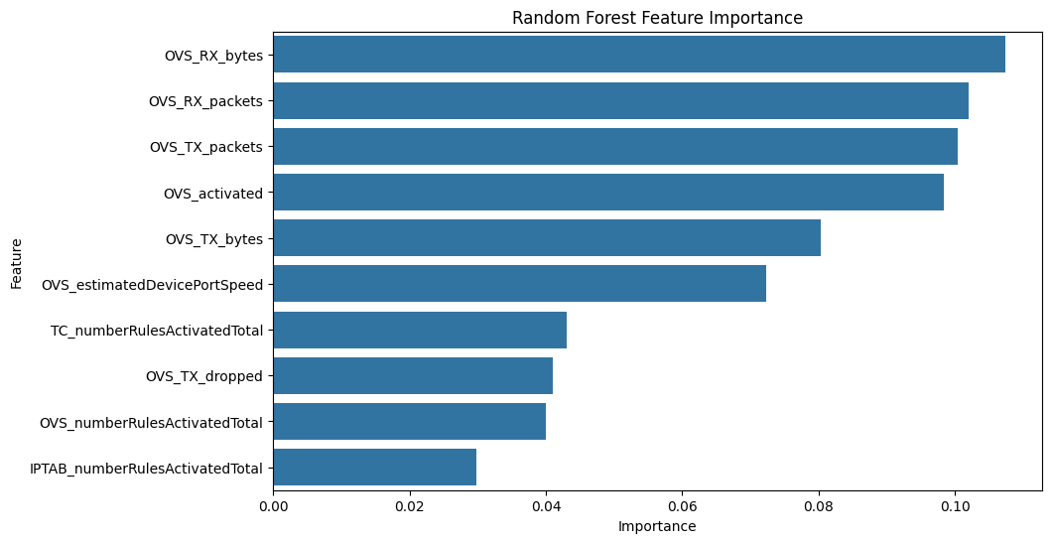

Figure 6.3.1: Random forest feature
(Source: Python)
The figure shows the analysis of the feature importance produced by the Random Forest classifier in the context of congestion prediction in the suggested 5G network management framework based on AI. The importance of the features indicates the relative value of each network parameter to the decision-making process of the model when classifying the congestion. The horizontal bar chart indicates that a number of Open vSwitch (OVS) traffic measures dominate in helping to determine the congestion conditions in the network. All variables have the greatest importance score, but OVS_RX_bytes has the highest importance score, meaning that the volume of incoming received bytes has the strongest impact on the prediction of congestion. This implies that the intensity of traffic loads and volume of packets entering the simulated 5G environment are closely related to the formation of congestion. In the same manner, both OVS_RX_packets and OVS_TX_packets have high values of importance thus validating the fact that the statistics of packet transmission and reception are very important in determining the behaviour of network traffic and the level of congestion.
OVS activated feature is also significant in the classification process. This means that Open vSwitch rules and forwarding mechanisms activation state impacts the routing performance and congestion dynamics. Moreover, OVS_TX_bytes and OVS estimated DevicePortSpeed prove to be moderately important, indicating that the transmission throughput and estimated port speed affect the overall efficiency of the network in terms of traffic. Other factors such as TC_numberRulesActivatedTotal, OVS_TX_dropped, and OVS_numberRulesActivatedTotal also form part of the model; however, their contribution to the model's performance is relatively insignificant. These factors are related to the traffic-control rules, packet drops, and the number of rules activated, respectively, and all these aspects have an indirect correlation with congestion-management operations within the SDN-enabled 5G architecture. In summary, an analysis of the importance of features provides further evidence in support of the statement that the key factors involved in the determination of congestion detection include traffic and switch operation factors.
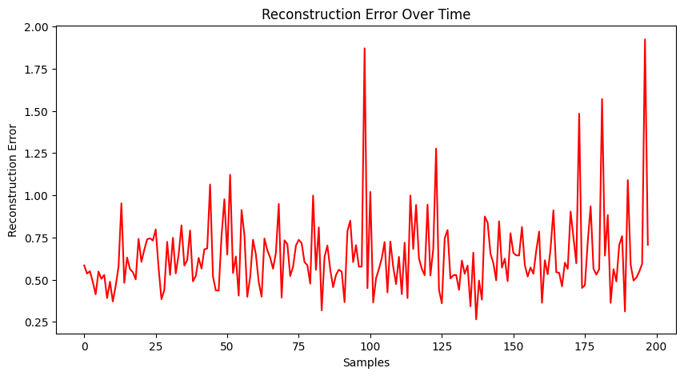

Figure 6.3.2: Reconstruction error over time
(Source: Python)
The figure shows the Reconstruction Error Over Time of the LSTM Autoencoder model, which is utilised to detect the congestion anomaly in the proposed AI-based 5G network structure. To illustrate this, reconstruction error is the value of the difference between the original input traffic sequence and the reconstructed output of the autoencoder model. Given that the autoencoder is trained to discover normal traffic behaviour patterns, greater reconstruction errors represent unusual or abnormal traffic behaviour that can be a congestion event or a network anomaly. The horizontal axis shows the order of samples worked on in the testing process, and the vertical axis shows the values of the reconstruction errors of the sample. The vast majority of the reconstruction error values are in a moderate range of about 0.4-0.8, which suggests that the model was able to reconstruct most of the normal network traffic patterns with a relatively low error. This indicates that the LSTM Autoencoder was successful in learning the temporal features of normal traffic behaviour in the 5G network setup.
However, there are a few sharp spikes in the graph, especially in samples 100, 170, 180 and 198, where the reconstruction error becomes larger and approaches values of above 1.5. These peaks are indications that the model was faced with some traffic patterns that were very different to the normal behaviour that it had learned. These deviations are explainable as bursts of congestion, deviant packets, bursts of traffic or even the possibility of the network having gone unstable. The changes evident in the graph also illustrate the dynamic and time-dependent nature of traffic conditions in the contemporary SDN-enabled 5G networks. The LSTM Autoencoder keeps a track of sequential traffic behaviour and determines abnormal conditions by a high value of reconstruction loss. The ability is especially useful in the detection of congestion in real time as it allows detecting the problematic state of the traffic early before the serious deterioration of the performance takes place. Altogether, the reconstruction error analysis proves the efficiency of the suggested deep learning architecture to detect anomalies in congestion and justifies the appropriateness of LSTM Autoencoders to monitor traffic and regulate the network in the next-generation 5G communication systems.
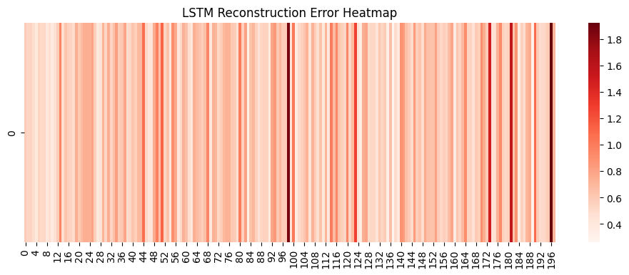

Figure 6.3.3: LSTM reconstruction error heatmap
(Source: Python)
The figure shows the LSTM Reconstruction Error Heatmap created by the LSTM Autoencoder model in the detection of anomalies to identify congestion in the proposed 5G network management framework. The heatmap image gives the visualisation of the reconstruction error intensity of various traffic samples, which allows finding abnormal traffic behaviour and congestion-related anomalies in the network more easily. The horizontal axis of the heatmap depicts the sequence samples that are being tested, and the vertical axis depicts the dimension of reconstruction error. Given that the visualisation has one row, the heatmap mainly highlights time differences in the values of reconstruction errors of the observed traffic sequences. The colour bar on the right shows the magnitude of reconstruction errors. The lighter the colour, the lower the reconstruction error and the darker the red, the greater the reconstruction error.
The areas on the heatmap are mostly light pink or moderate red in colour, which means that most of the traffic samples have been re-reconstructed by the LSTM Autoencoder with relatively low error. This implies that the network traffic in these periods had a similar pattern to the standard traffic behaviour obtained during the training of the model. These areas are thus associated with optimal network conditions with less congestion and effective transmissions. Nevertheless, there are a few dark red vertical bands that can be seen across the heatmap, especially around sample positions 100, 175, 182 and 198. These areas imply much greater reconstruction errors, such as the autoencoder did not reconstruct these traffic sequences correctly. These failures suggest the existence of some abnormal traffic patterns, bursts of packets, uncharacteristic routing or congestion-driven events in the SDN-based 5G network environment. The heatmap representation makes the results of the anomaly detection easier to interpret, as it visually indicates where the abnormal traffic conditions have occurred in time. The heatmap offers a more intuitive view of the distribution of the intensity of congestion throughout the dataset as compared to the conventional line plots. In general, the visualisation shows that the LSTM Autoencoder could be effective in detecting the hidden traffic anomalies and can be applied to develop intelligent real-time congestion monitoring and dynamic route optimisation systems in the next-generation 5G communication systems.
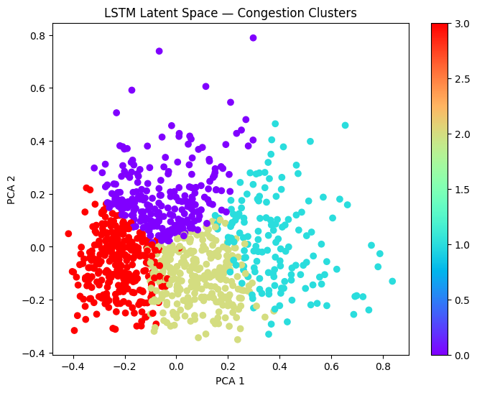

Figure 6.3.4: LSTM latent space
(Source: Python)
The figure shows the LSTM Latent Space Congestion Clusters, which were obtained after Principal Component Analysis (PCA) of the latent features produced by the LSTM Autoencoder model. The illustration shows how the deep learning architecture automatically learned and separated various traffic behavioural patterns in the SDN-enabled 5G network setup. The clustering analysis of the obtained latent representations of the encoder layer was carried out, and the high-dimensional features of the obtained latent representations were condensed into two main components (PCA 1 and PCA 2) to be visualised. The sample of the traffic sequences is represented by each point in the scatter plot, whereas the colours are used to show the clusters of congestion that can be identified by unsupervised learning algorithms like K-Means clustering. The graph shows that the traffic data has been categorised into four different clusters, and each cluster represents various states of network behaviour or different levels of congestion. The distance between clusters shows that the LSTM Autoencoder was able to learn meaningful hidden traffic features and temporal dynamics of the network data.
One of the types of traffic behaviour, which is mostly concentrated on the left side of the graph and is red in colour, is probably connected to the low or stable congestion environment. The purple cluster is located in the upper central area, and this means that there is another different pattern of traffic with moderate changes in network activity. The light green cluster can be seen as close to the centre and lower parts, and this depicts the transitional or medium congestion states. In the meantime, the cyan-colored cluster spreads in the right direction of the graph and is more dispersed, implying a more dynamic or highly congested traffic environment with a bigger variability. The sharp distinction between the clusters indicates the power of the latent-space learning process in separating the various congestion states without manual labelling. The PCA-based visualisation is also more interpretable as it is a simplified representation of the complex features of network traffic in a high-dimensional network. In general, the number confirms the ability of the suggested AI-based framework to discover concealed congestion structures, facilitate smart traffic classification, and make dynamic optimisation of routes to efficiently manage resources in the next-generation 5G communication systems.
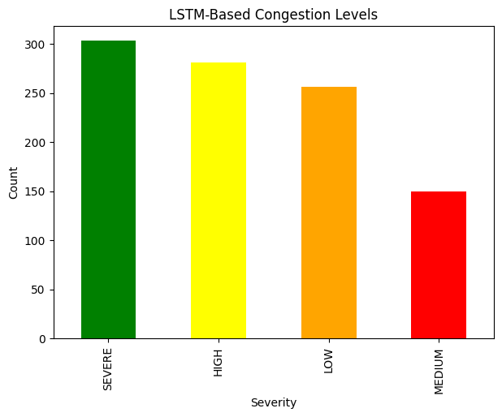

Figure 6.3.5: LSTM-based congestion levels
(Source: Python)
The figure shows the LSTM-Based Congestion Levels determined through the clustering analysis of latent features of the LSTM Autoencoder model. The bar chart was used to demonstrate the distribution of the various categories of congestion severity in the 5G network traffic dataset under analysis. The level of severity has four categories, which are SEVERE, HIGH, LOW, MEDIUM, each of which represents a specific traffic condition that the deep learning model has learned.
Categories of the severity of congestion are plotted as the horizontal axis, and the number of traffic samples associated with each category as the vertical axis. The bars are colour-coded to enhance the ease of interpretation whereby green indicates severe congestion, yellow indicates high congestion, orange indicates low congestion, and red indicates medium congestion conditions. Out of all the categories, the SEVERE congestion level has the largest number of samples with more than 300 observations. This implies that a large percentage of the traffic sequences analysed had features that correlated with the critical congestion conditions. These conditions can be related to overload with packets, bandwidth overload, higher delay of packets, or uncharacteristic bursts in traffic of the SDN-enabled 5G network.
The HIGH congestion type, too, has a significant number of samples, around 280 observations, which indicates that the network was often characterised by high traffic intensity and resource use. In the same way, the LOW congestion category demonstrates approximately 250 samples, which means that there are some fairly steady network states with the ability to manage traffic conditions and have a less significant impact on congestion. On the contrary, the MEDIUM level of congestion has the smallest number of samples, about 150 observations. This indicates that middle traffic conditions were less prevalent than severely congested or highly congested states. The asymmetry of congestion types indicates the changeable and dynamic behaviour of traffic in the next-generation communication networks. The findings show that the LSTM Autoencoder with clustering methods was capable of distinguishing among various levels of congestion severity and the complicated traffic patterns.
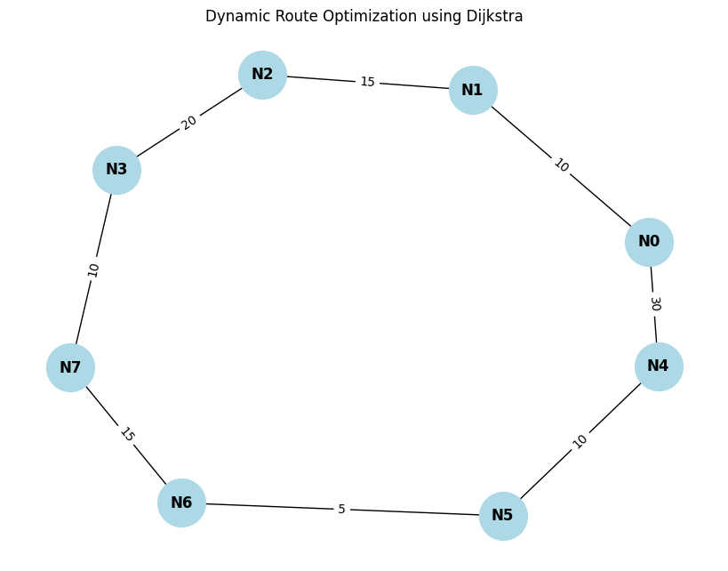

Figure 6.3.6: Dynamic route optimisation
(Source: Python)
The figure demonstrates the Dynamic Route Optimisation based on the Dijkstra algorithm in the congestion management framework proposed to be implemented by AI in 5G. The network graph is a simplified topology of communication made up of eight nodes connected and identified as N0-N7. The edges between nodes indicate a communication path, and the numbers placed on the links represent the routing cost and latency of data transmission between the nodes. The graph illustrates the process by which the shortest path algorithm used by Dijkstra will be used to find the most efficient path between the source and destination nodes in a congestion-aware network environment. The node connections define several possible routing paths, and they allow the optimisation framework to dynamically choose the path that has the lowest cumulative transmission cost. As an example, a possible route of N0 to N7 can be along the upper path via N1, N2 and N3, or it can be along the lower path via N4, N5 and N6.
The edge weights indicate the latency or congestion penalties of each network segment. The smaller values like the connection between N5 and N6 (cost = 5) are more efficient communication links, but larger values, like the connection between N0 and N4 (cost = 30) are more expensive or even congested. Dijkstra's algorithm is a constant estimation of weighted links to define the path that has the lowest total cost. The demonstration illustrates the real-world use of graph-based routing optimisation in Software-Defined Networking (SDN) and 5G networks. The framework can minimise latency, eliminate network segment congestion, and enhance the Quality of Service of latency-sensitive applications by dynamically choosing lower-cost paths. On the whole, the figure confirms the usefulness of intelligent routing optimisation methods of adaptive traffic management and real-time congestion control in the next-generation 5G communication systems.
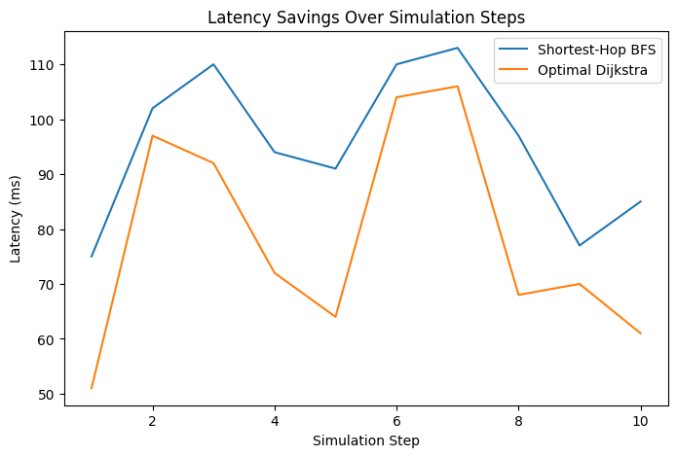

Figure 6.3.7: Latency savings over simulation steps
(Source: Python)
The figure shows the Latency Savings Over Simulation Steps obtained with the optimisation of the congestion-aware routing with the Dijkstra algorithm and with the routing based on the shortest path Breadth-First Search (BFS) algorithm. The graph compares the routing performance of the 10 simulation steps in the suggested AI-based 5G congestion management framework. The horizontal axis depicts the steps of the simulation, whereas the vertical axis depicts the network latency in milliseconds (ms). Two routing strategies are contrasted the blue line being the Shortest-Hop BFS routing strategy and the orange line being the Optimal Dijkstra congestion-aware routing strategy.
As can be seen in the graph, the routing technique based on Dijkstra shows lower values of latency in the majority of simulation steps in comparison with the conventional BFS routing technique. To illustrate, in simulation steps 1, 4, 5, 8, 9 and 10, the Dijkstra algorithm achieves a much lower transmission latency than shortest-hop routing. This shows that congestion-aware path optimisation is effective in choosing routes with a lower total transmission cost in preference to just minimising the number of hops. Both routing techniques are subject to variation based on the changing network conditions, but the BFS method is more likely to have high latency as it does not take into account the level of congestion or edge weights in selecting the path. However, the Dijkstra algorithm is dynamic and adjusts routing decisions by dynamically updating the weighted network costs, thus bypassing congested routes and enhancing the efficiency of traffic.

CHAPTER 6: DISCUSSION
This chapter focuses on the relevance of the results derived from the proposed AI-based real-time congestion detection and dynamic route optimization system to the 5G networks. The performance of the Random Forest classifier, LSTM prediction framework, LSTM Autoencoder with K-Means clustering, and congestion-aware routing optimization mechanisms introduced in the study are evaluated. The results achieved show the potential for using machine learning, deep learning, and intelligent routing algorithms to enhance congestion detection and adaptive traffic optimization in dynamic 5G scenarios. In this regard, the use of traffic management in modern wireless communication systems utilising artificial intelligence (Wang et al., 2020) has become increasingly significant. The mean accuracy of the Random Forest classifier in classification tasks for all traffic types (IPTABLES, OVS, and TC) was at the level of 98.5%, demonstrating adequate performance. From the results of the confusion matrix, it was observed that very few traffic samples were misclassified between the traffic categories. OVS traffic class had near-perfect values of precision and recall, and classification reliability for IPTABLES and TC was strong. The results show that the chosen traffic statistics carry highly discriminative information that can be used to capture network behavior specific to congestion effectively. The high level of classification accuracy is comparable with past works, showing the potential of machine learning in smart wireless network management. In 5G and beyond 5G systems, Wang et al. 2020) have stated that traffic analysis can be significantly enhanced by using AI. Thus, it is vital to ensure minimal numbers of false negatives because this would help in maintaining the stability of the network and continuing providing the communication services. Such a high classification accuracy is indicative of the effectiveness of the pre-processing pipeline in preparation of data for SDN-based traffic datasets. The confusion matrix analysis also showed that false negatives in the forecast of congestion were very small. Especially in practical communication systems, if the congestion goes unnoticed, it can result in higher latency, packet loss, and lower quality of service (QoS). Also, the analysis of the feature importance made it possible for us to get additional insights into the factors affecting the performance of the congestion prediction. According to the results obtained, the most important features in the random forest model included such factors as OVS_RX_bytes, OVS_RX_packets, OVS_TX_packets, and OVS_activated. These results demonstrate that traffic transmission and switching indicators could play a vital role in identifying congestion in the SDN environment. Additionally, the relevance of the traffic transmission metrics is confirmed by the fact that the amount of traffic and its switching play an important role in the occurrence of congestion within the intelligent 5G infrastructure. Moreover, the variables OVS_estimatedDevicePortSpeed, TC_numberRulesActivatedTotal and IPTAB_numberRulesActivatedTotal demonstrate that the traffic packet intensity is not a key factor in creating congestion; the traffic routing rules may also be responsible for creating network congestion. All of these findings are aligned with the topic of intelligent congestion control, which requires simultaneous monitoring of the mentioned parameters. The sequential learning capabilities of the LSTM-based predictive system made it possible to identify changes in the traffic patterns over time. The model can learn temporal relations and changing network traffic patterns over a relatively long period of time, which is something that cannot be achieved in conventional machine learning frameworks. There is no over-fitting and, as a consequence, the curves of training and validation losses are even, which means that the model is capable of generalisation. In addition, by applying the technique of regularisation using dropout and monitoring the validation process, it was possible to enhance the stability of the model and reduce its memorisation capacity.
The results obtained coincide with recent research that demonstrates the advantages of the LSTM-based models for traffic prediction. Kavehmadavani et al. (2022) concluded that the systems based on LSTM models possess the capability of learning patterns of dynamic traffic demand and optimising intelligent traffic steering in beyond-5G networks. They also discussed the issue of sequential learning in relation to traffic prediction and resource allocation. Through the study of the reconstruction error of the LSTM Autoencoder, abnormal traffic behaviors and congestion were successfully identified. Reconstruction error graphs revealed several peaks indicating very high reconstruction errors, thus suggesting that there was significant deviation from the norm for the traffic condition. This implies that there are certain patterns in traffic which the autoencoder could not correctly reconstruct and can be considered as possible incidents of traffic congestion. The reconstruction heatmap also showed the intensity and distribution of these anomalies over time, as they occurred throughout the dataset. The results of reconstruction-based anomaly detection are in line with the recent works carried out in an intelligent communication environment. Kouchaki et al. (2024) applied the use of recurrent neural network autoencoders in detecting anomalies in traffic within the context of 5G network traffic. They highlighted that reconstruction-based techniques are well-suited for real-time detection of anomalies as they define a baseline of normal traffic behavior and also dynamically detect anomalies that deviate from the learned behavior.
An important benefit of the proposed autoencoder framework is that it can detect anomalies unsupervisedly, without the need for fully labeled anomaly datasets. However, it is not easy to get precisely labelled congestion information in real-world communication systems since network traffic patterns are continually changing over time. The reconstruction-based analysis, therefore, enhances the scalability and adaptability because it is able to identify traffic anomalies that have not been previously observed dynamically. The PCA-based visualization of the latent space showed good separation between various levels of congestion. Successful extraction of meaningful representations of traffic from the encoded latent features produced by the LSTM Autoencoder allowed them to be clustered with K-Means into categories of LOW, MEDIUM, HIGH, and SEVERE congestion. This multi-level congestion classification is more realistic than the binary (congested or not) congestion classification, as in the real world, the congestion state continuously changes rather than switching between a normal state and a congested state. The congestion level distribution data also showed that there were high and severe levels of congestion in the dataset. This allows one to conclude that the chosen network environment was diverse enough to provide a basis for evaluating the performance of intelligent congestion management systems. Within modern communication systems, multi-level degradation estimation facilitates the adaptive management of traffic flow, rerouting traffic, and intelligent allocation of resources. The dynamic routing optimization framework showed that the system can be used in the practical scenario of the real-time intelligent networking environment. The Dijkstra-based congestion-aware routing algorithm was able to find optimized communication paths by taking into account the network latency and congestion weight. The Dijkstra optimization strategy always gave lower latency values than the shortest-hop BFS routing throughout the simulations. The visualisation clearly illustrated how visualisation reduced latency. Congestion-aware routing was shown to increase communication efficiency under various traffic conditions.
At the same time, the simulation results revealed that, from the perspective of congestion management, the shortest hop routing is not the most effective for communication. In BFS routing, the number of hops to destination nodes is minimised but this strategy does not take congestion into account, which leads to sending traffic via congested paths and increases latency. However, the Dijkstra-based routing, loaded with congestion information, makes it possible to achieve intelligent routing. The visualisation of the network graph made it possible to evaluate the flexibility of the proposed routing system. The congestion-aware routing simulations showed that the methods helped in avoiding highly congested nodes dynamically, and alternative communication paths were automatically chosen. This adaptive routing capability is significant in current 5G and edge-computing systems, where traffic conditions are ever-changing, and static routing approaches are ineffective. This study's key advantage is the combination of several different AI analytical methods into a single congestion management framework. The framework integrated all of the above (supervised learning, deep sequential learning, unsupervised anomaly detection, clustering analysis, and graph-based routing optimization) in one intelligent system. The multi-model integration enhanced the robustness of the framework since each analytical part dealt with a different aspect of the congestion management. Although the experimental performance was good throughout the study, there are some limitations to be recognized. First, the routing simulations were based upon a controlled experimental environment instead of a deployed real-world 5G infrastructure. While the simulations were successful in showing the congestion-aware optimization behavior, deploying such a system in the real world may have larger traffic scales and unpredictable environments. Secondly, LSTM Autoencoders are a deep learning architecture that can be more complex in ultra-dense network settings. There is thus a need to explore lightweight AI architectures and edge-optimized deployment strategies for enhanced computational efficiency in the future. Overall, the discussion verifies that the proposed AI-driven congestion detection and dynamic routing optimization framework was able to achieve the research goals. This Random Forest classification, LSTM temporal learning, Autoencoder anomaly detection, clustering-based congestion severity estimation, and congestion-aware Dijkstra routing yielded very promising results in terms of analytical and optimization results. The results obtained indicate promising potential practical applications for adaptive congestion monitoring, low-latency routing, and real-time network optimization in intelligent 5G and beyond-5G communication systems.

CHAPTER 7: CONCLUSION
This study introduced a new AI-driven, real-time congestion detection and optimization solution for 5G networks. Congestion management is key to sustaining network performance and Quality of Service (QoS) with the rapid proliferation of devices, data-intensive applications, and latency-sensitive services that are increasingly being used by today's modern communications network. Current congestion management approaches include simple methods based on predetermined thresholds or static routing, but these are not always effective in finding solutions to dynamically changing traffic patterns. In order to overcome these shortcomings, this research introduced an integrated approach to enable the adaptive congestion management in the 5G network environment. This also combines machine learning, deep learning, anomaly detection, clustering and intelligent routing. The increasing complexity of software-defined and virtualized network infrastructures in which traffic conditions often vary quickly as a result of fluctuations in user demand, service requirements, and the availability of network resources, formed the basis of the study. The proposed framework proposed to allow the use of artificial intelligence techniques, which can learn the traffic patterns, detect anomalies, classify congestion states and select routing decisions in a dynamic manner while enhancing congestion awareness. The framework aimed to offer an ‘all-in-one’ solution for intelligent monitoring and optimization in the networks with multiple analysis components simultaneously.
The first research goal was to create an effective congestion classification model, which is able to identify various types of network traffic states. The above-mentioned purpose was successfully achieved by applying network traffic metrics of the selected datasets to train a Random Forest classifier. The model shows outstanding classification performance with an overall accuracy of 98.5%. Confusion matrix results revealed that most traffic samples were well classified for the three traffic categories including IPTABLES, OVS and TC. The very low percentage of misclassified data and the high accuracy shows that the chosen network features carried a good amount of information predictive of congestion behaviour. The findings validate that machine learning based classification can be practically used for congestion detection in real-time in complex network environments. The second objective was to focus on temporal congestion prediction using the deep learning techniques. In order to achieve this objective, an LSTM based framework was developed to capture sequential traffic patterns and temporal dependencies within the network data. Both training and validation loss curves showed stable learning behaviour and how well the convergence proceeded during the training process. The LSTM model successfully learned the evolving traffic patterns that are often quite difficult to capture using conventional machine learning methods. Hence, this highlights the importance of temporal modelling in communication networks, where traffic conditions are influenced by historical behaviour and continuously changing operational factors.
The third was to discover abnormal traffic behaviour and congestion anomalies in an unsupervised learning fashion. This objective was solved by using LSTM Autoencoder which rebuilt the common traffic patterns and calculated the deviations by analysing reconstruction errors. Plotted reconstruction error plots and heatmaps were able to show abnormal traffic events and congestion spikes in the data set. Our method based on autoencoder was able to identify abnormal network conditions without any manually labelled abnormal data. This is especially relevant when deployed in the real world where it may be hard to obtain detailed labels for anomalies. Results indicated that reconstruction-based anomaly detection can be used as a good complementary method to smart congestion monitoring systems. The fourth aim was to provide a more detailed categorisation of congestion severity than a binary categorisation. This was done with Latent features extracted from the LSTM Autoencoder and applying dimensionality reduction and K-Means clustering to the same. The resulting clustering framework was able to successfully classify traffic conditions into several traffic severity levels, namely “LOW, MEDIUM, HIGH and SEVERE” traffic congestion state. The PCA-based visualization showed distinctiveness of congestion groups, suggesting that the latent representations contained meaningful information about the network conditions. This multi-level severity analysis offers more practical support to the intelligent network management as it allows a gradual adaptation and prioritization strategy to be used depending on the congestion that is being encountered and not all congestion events are treated equally. The ultimate goal was the dynamic optimization of routes by deploying congestion aware route optimization algorithms. A graph-based networking model was designed and used to simulate traffic rerouting, for various traffic conditions. Dijkstra was used for the routing mechanism with weights related to the congestion and considering latency. These simulation results showed that the congestion-aware routing approach could always run at a lower latency than shortest-hop routing approaches. The visualization also showed the routing capabilities, allowing the network to adjust according to the conditions. These results validate that intelligent routing strategies have the potential to significantly enhance the communication efficiency and to proactively manage the traffic in a 5G environment.
Overall, this study highlights the significance of AI in communication networks today. Network infrastructures will be significantly more data-driven and complex in “5G” systems and even more so in “6G” systems that will be defined in the future. Conventional rule-based management approaches might be unable to react appropriately to infrastructure with far more activated devices, various services, and extreme requirements of performance. AI solutions have several benefits, including learning from the past, adapting to varying conditions, and aiding in decision-making. Thus, the proposed framework is a viable approach to building intelligent, self-optimizing networks that are able to address congestion points in a proactive and efficient manner. This dissertation has successfully shown the feasibility and effectiveness of the presented AI based real-time congestion detection and dynamic route optimization framework for 5G networks. In the case of the proposed system, a high degree of accuracy in congestion classification, effective temporal traffic prediction, reliable anomaly detection, meaningful congestion severity classification with an intelligent routing optimization were demonstrated. The combination of machine learning, deep learning, clustering, and graph-based routing techniques resulted in a holistic congestion management solution that could tackle several of the congestion issues raised by communication networks nowadays. The outcomes reflect the great potential of artificial intelligence for improving network intelligence, network management, decreasing latency and enabling the construction of future autonomous communication networks. With the ongoing deployment of 5G and future generation networking technologies, intelligent congestion management schemes like the proposed one in this study will become more crucial in order to guarantee reliable, efficient and adaptive operations of the network.

REFERENCES
Alshawki, M. B., Najm, I. A., & Hamoud, A. K. (2024). Congestion Control Prediction Model for 5G Environment Based on Supervised and Unsupervised Machine Learning Approach. IEEE Access, 12, 91127-91139. https://doi.org/10.1109/ACCESS.2024.3416863
Bhattacharjee, I. (2025). Ai-driven routing: Transforming network efficiency and resilience. doi: https://doi.org/10.20944/preprints202502.2005.v1
Boubaker, S., Al-Dahidi, S., Kamel, S., Ghazouani, N., Kraiem, H., Alsubaei, F. S., ... & Mellit, A. (2025). Electric vehicles charging station allocation based on load profile forecasting and Dijkstra’s algorithm for optimal path planning. Scientific Reports, 15(1), 23844. https://doi.org/10.1038/s41598-025-08840-3
Brito, J. A., Moreno, J. I., Contreras, L. M., Alvarez-Campana, M., & Blanco Caamaño, M. (2023). Programmable data plane applications in 5G and beyond architectures: A systematic review. Sensors, 23(15), 6955. https://doi.org/10.3390/s23156955
Chabira, C., Shayea, I., Nurzhaubayeva, G., Aldasheva, L., Yedilkhan, D., & Amanzholova, S. (2025). AI-driven handover management and load balancing optimization in ultra-dense 5G/6G cellular networks. Technologies, 13(7), 276. https://doi.org/10.3390/technologies13070276
Chandra Bikkasani, D. (2024). AI-driven 5G network optimization: A comprehensive review of resource allocation, traffic management, and dynamic network slicing. https://doi.org/10.20944/preprints202410.2084.v1
Cruz, M., Carvalho, R., Costa, A., Pinto, L., Dias, L., Cerqueira, P., ... & Ribeiro, J. (2025). A Contribution of Shortest Paths Algorithms to the NetworkX Python Library. Applied Sciences, 15(15), 8273. https://doi.org/10.3390/app15158273
Deng, Y. (2025). A hybrid network congestion prediction method integrating association rules and LSTM for enhanced spatiotemporal forecasting. Transactions on Computational and Scientific Methods, 5(2). https://www.pspress.org/index.php/tcsm/article/download/187/140
GitHub, (2024). Iw-ib-5gnet. [Online]. Accessed on 22 May 2026. Available at https://github.com/jimenaandrade/iw-ib-5gnet
Gómez, B., Coronado, E., Villalón, J., & Garrido, A. (2024). Energy-focused simulation of edge computing architectures in 5G networks: B. Gómez. The Journal of Supercomputing, 80(9), 12564-12584. https://doi.org/10.1007/s11227-024-05926-z
Gonzalez, L. F., Vidal, I., Valera, F., Martin, R., & Artalejo, D. (2023). A link-layer virtual networking solution for cloud-native network function virtualisation ecosystems: L2S-M. Future Internet, 15(8), 274. https://doi.org/10.3390/fi15080274
James Okeda, O. (2025). AI-Driven Network Management and Optimization: An Exploratory Literature Review. ScienceOpen Preprints. DOI: https://doi.org/10.14293/pr2199.002391.v1
Jiang, W., Han, H., Zhang, Y., Wang, J. A., He, M., Gu, W., ... & Cheng, X. (2024). Graph neural networks for routing optimization: Challenges and opportunities. Sustainability, 16(21), 9239. https://doi.org/10.3390/su16219239
Jiang, X., Liu, S., Gember-Jacobson, A., Bhagoji, A. N., Schmitt, P., Bronzino, F., & Feamster, N. (2024). Netdiffusion: Network data augmentation through protocol-constrained traffic generation. Proceedings of the ACM on Measurement and Analysis of Computing Systems, 8(1), 1-32. https://doi.org/10.1145/3639037
Kavehmadavani, F., Nguyen, V.-D., Vu, T. X., & Chatzinotas, S. (2022). Intelligent Traffic Steering in Beyond 5G Open RAN based on LSTM Traffic Prediction (Version 1). arXiv. https://doi.org/10.48550/ARXIV.2210.08829
Khan, M. F., Yau, K. L. A., Ling, M. H., Imran, M. A., & Chong, Y. W. (2022). An intelligent cluster-based routing scheme in 5G flying ad hoc networks. Applied Sciences, 12(7), 3665. https://doi.org/10.3390/app12073665
Khan, N. A. (2022). 5G network: Techniques to increase quality of service and quality of experience. Int. J. Comput. Netw. Appl.(IJCNA), 9, 476-496. DOI: 10.22247/ijcna/2022/214508
Khan, O. G. M., Youssef, A., El-Saadany, E., & Salama, M. (2021). LSTM-based approach to detect cyber attacks on market-based congestion management methods (Version 1). arXiv. https://doi.org/10.48550/ARXIV.2109.13312
Khattab, O., Saravana Balaji, B., Alghadhoori, F., AlMazyad, F., AlDousari, M., Al-Ameeri, A., & Al-Kadri, M. O. (2025). Real time urban traffic prediction using RFID and a hybrid LSTM random forest model. Scientific Reports, 15(1), 43722. https://doi.org/10.1038/s41598-025-27485-w
Kim, Y., Kwon, B. A., & Kang, K. (2024). Assessing the Impact of Data Impurity Measures on Decision Tree Algorithms in Spam Classification. Journal of Artificial Intelligence Research and Applications, 1(2), 33-46. https://www.e-jara.org/journal/download_pdf.php?spage=33&volume=1&number=2
Kouchaki, M., Zhang, M., Abdalla, A. S., Lan, G., Brinton, C. G., & Marojevic, V. (2024). Enhanced Real-Time Threat Detection in 5G Networks: A Self-Attention RNN Autoencoder Approach for Spectral Intrusion Analysis (Version 1). arXiv. https://doi.org/10.48550/ARXIV.2411.03365
Lachekhab, F., Benzaoui, M., Tadjer, S. A., Bensmaine, A., & Hamma, H. (2024). LSTM-autoencoder deep learning model for anomaly detection in electric motor. Energies, 17(10), 2340. https://doi.org/10.3390/en17102340
Lykakis, E., Vardiambasis, I. O., & Kokkinos, E. (2025). Data Traffic Prediction for 5G and Beyond: Emerging Trends, Challenges, and Future Directions: A Scoping Review. Electronics, 14(23), 4611. https://doi.org/10.3390/electronics14234611
Maftei, A. A., Petrariu, A. I., Popa, V., & Lavric, A. (2025). A Blockchain Framework for Scalable, High-Density IoT Networks of the Future. Sensors, 25(9), 2886. https://doi.org/10.3390/s25092886
Mahjoub, S., Chrifi-Alaoui, L., Marhic, B., & Delahoche, L. (2022). Predicting energy consumption using LSTM, multi-layer GRU and drop-GRU neural networks. Sensors, 22(11), 4062. https://doi.org/10.3390/s22114062
Mobtahej, P., Zhang, X., Hamidi, M., & Zhang, J. (2022). An LSTM‐Autoencoder Architecture for Anomaly Detection Applied on Compressors Audio Data. Computational and Mathematical Methods, 2022(1), 3622426. https://doi.org/10.1155/2022/3622426
Nachouki, M., Mohamed, E. A., Mehdi, R., & Abou Naaj, M. (2023). Student course grade prediction using the random forest algorithm: Analysis of predictors' importance. Trends in Neuroscience and Education, 33, 100214. https://doi.org/10.1016/j.tine.2023.100214
Nashaat, H., Mohammed, N. H., Abdel-Mageid, S. M., & Rizk, R. Y. (2024). Machine learning-based cellular traffic prediction using data reduction techniques. Ieee Access, 12, 58927-58939. Digital Object Identifier 10.1109/ACCESS.2024.3392624
Oleiwi, A. H. (2025). Artificial Intelligence Approaches to Mitigating Network Congestion in IoT Systems. Babylonian Journal of Artificial Intelligence, 2025, 117-127. https://doi.org/10.58496/BJAI/2025/011
Olufemi, D., Ejiade, A. O., Ikwuogu, F. O., Olufemi, P. E., & Bobie-Ansah, D. (2025). Securing Software-Defined Networks (SDN) Against Emerging Cyber Threats in 5G and Future Networks–A Comprehensive Review. Article in International Journal of Engineering Research. https://www.researchgate.net/profile/David_Olufemi2/publication/389946028_Securing_Software-Defined_Networks_SDN_Against_Emerging_Cyber_Threats_in_5G_and_Future_Networks_-A_Comprehensive_Review/links/67da2ca37c5b5569dcc0e682/Securing-Software-Defined-Networks-SDN-Against-Emerging-Cyber-Threats-in-5G-and-Future-Networks-A-Comprehensive-Review.pdf
Ordóñez Lucena, J. A. (2022). Management and Orchestration of Network Slicing in Public-Private 5G Networks (Doctoral dissertation, Universidad de Granada). https://digibug.ugr.es/bitstream/handle/10481/77685/79489%281%29.pdf?sequence=4
Priyambudi, Z. S., & Nugroho, Y. S. (2024, January). Which algorithm is better? An implementation of normalization to predict student performance. In AIP Conference Proceedings (Vol. 2926, No. 1, p. 020110). AIP Publishing LLC. https://doi.org/10.1063/5.0182879
Purnamasari, E., & Nurwildani, M. F. (2025). Efficient graph-based algorithm for real-time traffic flow optimization in smart cities. ALCOM: Journal of Algorithm and Computing, 1(1), 45-53. http://doi.org/10.26594/register.v6i1.idarticle
Rahimi, H., Picaud, Y., Singh, K. D., Madhusudan, G., Costanzo, S., & Boissier, O. (2021). Design and simulation of a hybrid architecture for edge computing in 5G and beyond. IEEE Transactions on Computers, 70(8), 1213-1224. https://arxiv.org/pdf/2009.00041
Ramezanpour, K., & Jagannath, J. (2021). Intelligent Zero Trust Architecture for 5G/6G Networks: Principles, Challenges, and the Role of Machine Learning in the context of O-RAN (Version 3). arXiv. https://doi.org/10.48550/ARXIV.2105.01478
Saeed, H., Askar, S., Soran, Z., & Khosnawi, D. (2024). Comparative Evaluation of VXLAN with Traditional Overlay Network Protocols. The Indonesian Journal of Computer Science, 13(2). http://ijcs.net/ijcs/index.php/ijcs/article/download/3852/552
Salau, A. O., & Beyene, M. M. (2024). Software defined networking based network traffic classification using machine learning techniques. Scientific reports, 14(1), 20060. https://doi.org/10.1038/s41598-024-70983-6
Saxena, S. (2025). GLOBAL JOURNAL OF ADVANCED ENGINEERING TECHNOLOGIES AND SCIENCES ENHANCING 5G NETWORK EFFICIENCY: AN AI-BASED APPROACH TO DYNAMIC RESOURCE ALLOCATION, ANOMALY DETECTION, AND LATENCY REDUCTION. https://doi.org/10.29121/gjaets.2025.4.1
Sayed, A. (2025). Intelligent optimization of LTE and 5G networks using AI and machine learning. International Journal of Artificial Intelligence, Data Science, and Machine Learning, 6(3), 24-31. https://doi.org/10.63282/3050-9262.IJAIDSML-V6I3P104
Simpson, T., Dervilis, N., & Chatzi, E. (2021). Machine learning approach to model order reduction of nonlinear systems via autoencoder and LSTM networks. Journal of Engineering Mechanics, 147(10), 04021061. https://doi.org/10.1061/(ASCE)EM.1943-7889.0001971
Singh, G., Srivastava, A., Bohara, V. A., Noor-A-Rahim, M., Liu, Z., & Pesch, D. (2024). Toward 6G-V2X: Aggregated RF-VLC for ultra-reliable and low-latency autonomous driving. IEEE Communications Standards Magazine, 8(4), 80-87. https://arxiv.org/pdf/2208.06287
Tshakwanda, P. M., Arzo, S. T., & Devetsikiotis, M. (2024). Advancing 6g network performance: Ai/ml framework for proactive management and dynamic optimal routing. IEEE open journal of the computer society, 5, 303-314. DOI: https://doi.org/10.1109/ojcs.2024.3398540
Umar, A., Khalid, Z., Ali, M., Abazeed, M., Alqahtani, A., Ullah, R., & Safdar, H. (2023). A review on congestion mitigation techniques in ultra-dense wireless sensor networks: state-of-the-art future emerging artificial intelligence-based solutions. Applied Sciences, 13(22), 12384. https://doi.org/10.3390/app132212384
Wang, C.-X., Di Renzo, M., Stańczak, S., Wang, S., & Larsson, E. G. (2020). Artificial Intelligence Enabled Wireless Networking for 5G and Beyond: Recent Advances and Future Challenges (Version 1). arXiv. https://doi.org/10.48550/ARXIV.2001.08159
Yang, J., Chen, X., & Dong, M. (2025). Integration field-based breadth-first search for flow field pathfinding: J. Yang, X. Chen, M. Dong. Scientific Reports, 15(1), 40580. https://doi.org/10.1038/s41598-025-24412-x
Zeng, L., Ye, S., Chen, X., Zhang, X., Ren, J., Tang, J., ... & Shen, X. (2025). Edge graph intelligence: Reciprocally empowering edge networks with graph intelligence. IEEE Communications Surveys & Tutorials, 27(6), 3417-3454. https://arxiv.org/pdf/2407.15320?
Zulfiqar, M., Gamage, K. A., Rasheed, M. B., & Gould, C. (2024). Optimised deep learning for time-critical load forecasting using LSTM and modified particle swarm optimisation. Energies, 17(22), 5524. https://doi.org/10.3390/en17225524

